**Adding Derivation Rules and Join Paths**

**in NORMA**

*Terry Halpin*

**Contents**

1. **Adding Subtype Derivation Rules 1**
   1. Introduction 1
   2. A Simple Example of Adding a Subtype Derivation Rule 4
   3. Derivation Rules with a Value Equality 9
   4. Derivation Rules with Other Value Comparisons 12
   5. Derivation Rules involving Multiple Inheritance 16
   6. Derivation Rules with Negation 19
   7. Derivation Rules with Disjunction 23
   8. Simplifying Subtype Navigation 26
   9. Semiderived Subtypes 28
2. **Adding Fact Type Derivation Rules 31**
   1. Introduction 31
   2. Projecting from a Linear path 34
   3. Correlating Path Variables 38
   4. Recursive Rules 42
   5. Simple Calculations 47
   6. Aggregate Functions 50
   7. Nested Calculations 54
   8. Joining from Multiple Roles of an *n*-ary Fact Type 59
   9. Objectification 61
   10. Cartesian Products 67
   11. Multi-pathed Derivation Rules 70
   12. Shared Path Derivation Rules 76
   13. Semiderived Fact Types 79
   14. Modifying Derivation Rules 81
3. **Adding Join Paths for Constraints 85**
   1. Introduction 85
   2. A Worked Example 86

# Adding Subtype Derivation Rules

## Introduction

In ORM, subtypes may be asserted, derived, or semiderived. A subtype is *asserted* if and only if, for each state of the fact base, only asserted instances may appear in its population. A subtype is *derived* if and only if, for each state of the fact base, only derived instances may appear in its population. A subtype is *semiderived* if and only if some of its instances may be simply asserted and some other instances may be derived. Graphically, derived subtypes are displayed with an asterisk “*” after their name, and semiderived subtypes are displayed with a plus superscript “**+**” after their name.

Consider the ORM schema in Figure 1‑1(a). Here the subtypes are simply asserted, since there is no way to derive which persons are smokers and which persons are males. In contrast, the ORM schema in Figure 1‑1(b) includes smokes and gender fact types that enable us to derive which persons are members of which subtypes. In this case, we must declare the subtypes to be derived and provide appropriate derivation rules for the subtype definitions. Otherwise, it would be possible to have incorrect models. For example, we could declare an instance of Smoker without having that person play the smokes role; or we could declare an instance of MalePerson for a person with gender code ‘F’.



Figure ‑ ORM schemas with (a) asserted subtypes, and (b) subtypes that should be derived

The ORM schema in Figure 1‑2 marks the subtypes as derived, and expresses their derivation rules in the syntax of FORML (Formal ORM Language), a formal, textual language for ORM that is currently under development. Here pseudo-reserved words are displayed in bold.



Figure ‑ ORM schema with derived subtypes and derivation rules

While a future version of NORMA might support the use of FORML as a textual language for inputting complete ORM models (including constraints and derivation rules) and queries, NORMA’s current support for FORML as an input language is limited to input of fact types and object types (via the Fact Editor). However, NORMA currently provides fairly extensive support for FORML as an output language (via the Verbalization Browser). The verbalization is currently limited to relational style (using predicate readings rather than attribute style based on role names) and is sometimes more verbose than needed to ensure unambiguity.

Figure 1‑3 shows an ORM schema in which Grandparent is semiderived subtype. If we know that person1 is a parent of person2 and that person2 is a parent of person3, then the fact that person1 is a grandparent can be derived. This schema also allows us to simply assert that some specific person is a grandparent without knowing the relevant parenthood facts.



Figure ‑ ORM schema with a semiderived subtype and its derivation rule

While one can declare that a subtype is derived simply by entering some text in the DerivationNote property for the subtype in the ORM Model Browser, derivation notes are treated by NORMA simply as informal comments, so no code will be generated from them to enforce the derivation rules. Currently, the only way to formally declare a derivation rule in NORMA is to specify a *derivation path* for it in the ORM Model Browser. The rest of this chapter discusses how to enter subtype derivation paths in NORMA.

*A subtype’s derivation path is the path through the ORM schema, including any operators and conditions that apply, that corresponds to the subtype derivation rule*. The path always starts at an object type, known as the *root object type* for the path. For subtype derivation paths, the root object type will always be a supertype of that subtype. With complex paths, you might need to traverse through the same role more than once, in which case we need to distinguish different occurrences of the same role. When this is not the case, the term “role” is often used informally for “role occurrence”.

For the Smoker subtype in Figure 1‑2, the derivation path is the path starting at Person (the root object type for the path) and ending at the role in the smokes predicate. You can visualize it as shown in Figure 1‑4. More complex subtype definitions may have derivation paths that look like a tree, with multiple branches stemming from the root object type or from object type occurrences later in the path.



Figure ‑ The derivation path for the Smoker subtype in

The remaining sections of this chapter discuss several examples of how to add derivation rules for subtypes using NORMA. The completed ORM schemas for these examples are available in the following NORMA files, listed by section number. You may work through the examples interactively with NORMA by first deleting the Derivation Path, and then following the step-by-step procedure outlined in the section for the relevant example.

To remove the derivation path for a subtype, right-click the subtype shape in the Document window, choose Select in Model Browser form its context menu, then select the Derivation Path header for that subtype in the Model Browser and press the delete key (or right-click the derivation path header and choose Delete From Model).

|  |  |
| --- | --- |
| *Section* | *NORMA file* |
| 1.2  1.3  1.4  1.5  1.6  1.7  1.8  1.9 | Derivation1_SmokerSubtype.orm  Derivation2_MalePersonSubtype.orm  Derivation3_TeenagerEtcSubtypes.orm  Derivation4_MaleSmokerSubtype.orm  Derivation5_MaleSmokerSubtype2.orm  Derivation6_NonSmokerEtcSubtypes.orm  Derivation7_ResidentEtcSubtypes.orm  Derivation8_FemaleManagerSubtype.orm  Derivation9_GrandparentSubtype.orm  Derivation10_GrandparentSubtype2.orm |

**Keyboard Shortcuts**

In this document, discussion on how to open menus, windows and drop-down lists typically assumes you are using a mouse (e.g. right-click an element to open its context menu). If you prefer to use keyboard shortcuts[1], also known as accelerator keys or hot keys, some common ones relevant to NORMA are noted here.

To invoke the context menu, press the *context menu key*. On a full Windows keyboard, this key has an icon similar to that shown opposite, and is typically located to the left of the right control (Ctrl) key. If you press this key and then the “W” key, the ORM Tool Windows menu will display as shown below (if the context is a blank space in the Drawing window).

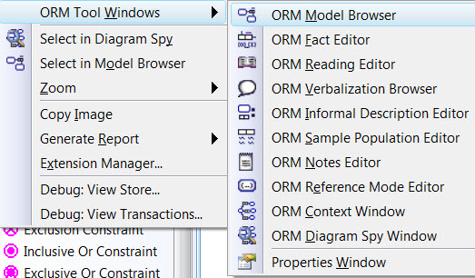

Because you invoked the menu by using the context menu key, the display underlines the relevant letters used to invoke further options. For example, pressing “F” will now open the Fact Editor. If instead you press “V” this opens the Verbalization Browser. If instead you press “N” this opens the Notes Editor. It doesn’t matter whether these letters are uppercase (e.g. “N”) or lowercase (e.g. “n”), so there is no need to hold the Shift key down. Nor do you need to hold down the context menu key as you press the following letter keys.

As an alternative to using the context menu key, if you *hold the control key down while you press the relevant two letter sequence* (as shown below) you will get the same effect. You can also press Ctrl+W, then release the control key, then hold the control key down as you press the next letter key. Using “ContextMenu” for the context menu key, the following key stroke patterns may be used to perform the listed action.

|  |  |  |
| --- | --- | --- |
| *Action* | *Keyboard Shortcut* | *Alternative Shortcut* |
| Open context menu for current selection  Open the Model Browser  Open the Fact Editor  Open the Reading Editor  Open the Verbalization Browser  Open the Informal Description Editor  Open the Sample Population Editor  Open the Notes Editor  Open the Reference Mode Editor  Open the Context Window  Open the Diagram Spy Window  Open the Properties Window | Shift + F10  Ctrl + WM  Ctrl + WF  Ctrl + WR  Ctrl + WV  Ctrl + WI  Ctrl + WS  Ctrl +WN  Ctrl +WE  Ctrl +WC  Ctrl +WD  Ctrl + WW | ContextMenu  ContextMenu W M  ContextMenu W F  ContextMenu W R  ContextMenu W V  ContextMenu W I  ContextMenu W S  ContextMenu W N  ContextMenu W E  ContextMenu W C  ContextMenu W D  ContextMenu W W |

*Update Note:* At the time of writing, NORMA has just added the ability to automatically determine role bindings to path variables for many derived fact type and join path cases. In this document, all role binding steps are performed manually, even if no longer needed.

## A Simple Example of Adding a Subtype Derivation Rule

As a simple example of adding a subtype derivation rule in NORMA, consider the ORM schema opposite. At this stage, the Smoker subtype has no derivation rule, and is not marked as derived.

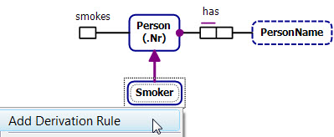To enter a derivation rule for the Smoker subtype, right-click the subtype shape, and select Add Derivation Rule from its context menu[2].

In the Document Window, NORMA now adds an asterisk to the Smoker subtype shape to indicate that it is derived. In the ORM Model Browser[3], a Derivation Path option preceded by a “winding path” icon appears below Smoker, and a dialog opens for you to select the root object type for the derivation.

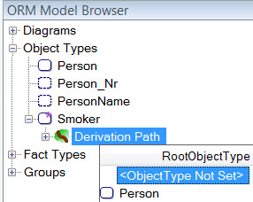

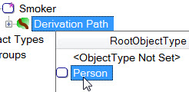In this case, we wish to define a smoker as a person who smokes. So all we need do to declare the derivation path is to start with Person as the root object type and then navigate to its smokes role. Choose Person by double-clicking it, or by selecting it and pressing Enter.

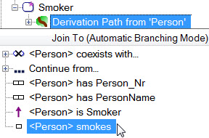A Join To (Automatic Branching Mode) dialog opens for you to continue the derivation path from Person. Automatic Branching Mode guarantees that the paths entered are properly connected via joins, so long as the underlying model is unchanged[4]. You now need to choose a role to continue the path. NORMA displays each role in angle brackets (e.g. “<Person>”) within its fact type. Choose Person’s role in the fact type Person smokes by double-clicking it, or by selecting it and pressing Enter.

If the same object type plays more than one role in the same fact type, the fact type would be displayed multiple times, with the relevant role in angle brackets. For example, if we added the fact type Person likes Person to the schema, we would see the following displayed: <Person> likes Person (for choosing the first role), and Person likes <Person> (for choosing the second role).

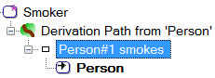Whenever you add a role occurrence to the path, NORMA appends a number to distinguish that occurrence from others based on the same object type. In this case, NORMA automatically appends “#1” to “Person” in displaying this occurrence of the Person smokes fact type. That completes the derivation path.

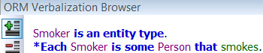Now select the Smoker subtype shape on the diagram, and open the Verbalization Browser. The derivation rule that you just entered in the ORM Model Browser is verbalized as “\***Each** Smoker is **some** Person **that** smokes”.

To improve the verbalization, select the Person shape, and in the Properties window toggle its IsPersonal property entry from False to True, either by double-clicking the entry or by selecting True from the drop-down list. This ensures that the personal pronoun “**who**” is used instead of “**that**” for Person and its subtypes where relevant in verbalizations.

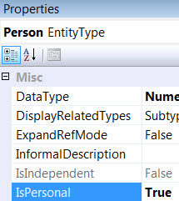

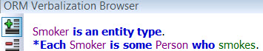

⇨

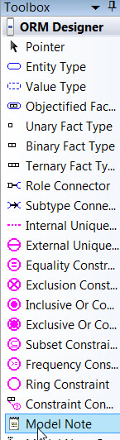Derivation rules entered in the ORM Model Browser are automatically verbalized, but these verbalizations are displayed only in the Verbalization Browser, not in the Document window which displays the ORM diagram. To see a derivation rule on the diagram, include it in a Model Note. Select the Model Note icon from the Toolbox, and drag[5] it to a position near the Smoker subtype shape.

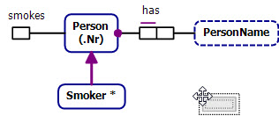

If the ORM Notes Editor is not already open and selected, right-click anywhere to invoke the context menu, then select ORM Tools Windows > ORM Notes Editor. Alternatively, press Ctrl+WN.

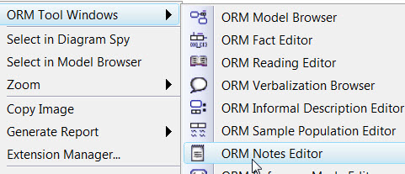

One way to enter the derivation rule in the model note is to copy its verbalization from the Verbalization Browser. First, select the Smoker subtype, open the Verbalizer, select the derivation rule text, and press Ctrl+C to copy it to the clipboard.

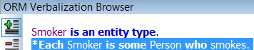

Now *select the empty Model Note shape*, open the ORM Notes Editor and press Ctrl+V to paste the text into the Notes Editor.

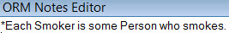

The derivation rule is now displayed in the Model Note, with an extra blank line, as shown. If you did not select the model note shape before pasting the rule text, it would instead have been pasted into the Notes field in the Properties window for the subtype (since the paste would have occurred in the context of the subtype shape selection rather than the model note selection).

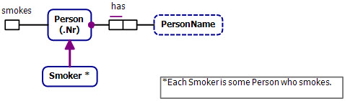

To remove the blank line, select the note shape, and then in the Notes Editor go to the final line and press the Backspace key. The note is now displayed without the extra line. If you wish to connect the note shape to the subtype shape, click the Model Note Connector from the Toolbox, then click the model note shape, then click the Smoker subtype shape.

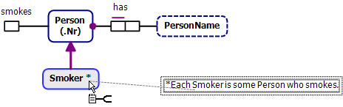

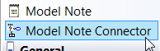

The note is now displayed with a dotted line connecting it to the subtype shape. You can reposition the model note shape wherever you like by dragging the shape to the desired position. The connector will adjust accordingly.

Another way to enter a derivation rule in a model note is to simply type it in manually. One reason to do so is to display a more readable version of the derivation rule than the one that is automatically generated in the verbalization. Another reason is to formulate the rule in your own mind and see this depicted visually before entering the derivation rule in the Model Browser. This “double entry” procedure can be quite helpful for entering complex rules. You can write the rule notes in any syntax that is intelligible to you, but FORML syntax is used in our examples. You can also add whatever comments you like to the model note.

Another option for displaying derivation rules in model notes is to start by copying the verbalized form of the rule to the model notes as discussed earlier, and then edit the text if desired to provide a more natural reading. As a trivial example, let’s replace “some” by “a” in the model note for Smoker.

To do this, select the note shape, then open the Notes Editor, replace “some” by “a”, and click the Document window again to see the change. Updating a model note in this way has no impact on the generated verbalization of the derivation rule.

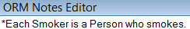

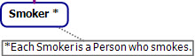

Because the subtype is marked as fully derived, and this is the only derivation rule provided for it, the rule is interpreted strongly as a *subtype definition*. So being a person who smokes is both necessary and sufficient for an object to be a smoker. In other words, an object is a smoker *if and only if* it is a person who smokes.

If you wish to add further explanatory text regarding the derivation and wish to see it on the ORM diagram, you can include that as part of the model note. You can also add comments about the derivation in the subtype’s DerivationNote property. By default, entries in the DerivationNote field are not displayed on the diagram[6], but they are included in the verbalization for the subtype. When using the free, public domain version of NORMA, derivation rules can be entered only as derivation notes, since support for formal derivation paths is provided only in the professional version of NORMA.

If a derivation note is supplied for a subtype, the subtype will be marked on the diagram as derived (or semiderived if that option is chosen—see later), but no code will be generated to enforce the derivation rule, since derivation notes are treated simply as comments.

At the time of writing, derivation rules entered as formal derivation paths in NORMA Professional do not yet generate implementation code for relational databases. However, derivation paths are stored in a formal structure from which mapping to relational databases and other implementation targets are planned for a future release.

## Derivation Rules with a Value Equality

Now consider the ORM schema shown in Figure 1‑5. Here the derivation rule for the MalePerson subtype is expressed in FORML thus: **\*Each** MalePerson **is a** Person **who** has Gender ‘M’. Since Gender has Code as its popular reference mode, in FORML, the restriction “Gender ‘M’” is understood as convenient shorthand for “**a** Gender **that** has **a** GenderCode **that is represented by the** CharacterString ‘M’”. Hence the derivation rule for MalePerson requires the string constant representing the gender code of any male person to equal the specific value ‘M’. The rest of this section discusses how to enter the derivation rule as a formal derivation path in NORMA.



Figure ‑ The derivation rule for MalePerson requires the gender code to equal a specific value

To get started, right-click the MalePerson subtype shape, and select Add Derivation Rule from its context menu. An asterisk appears on the subtype shape to indicate that it is derived, and a Derivation Path is opened for MalePerson in the ORM Model Browser. Press the drop-down arrow to the right of the derivation path header (if needed, press F2 to display the arrow), then double-click Person from the drop-down list to select it as the root object type for the derivation path. As a shortcut, you can press Alt+↓ (hold an Alt key down as you press the down-arrow key) to open the drop-down dialog.

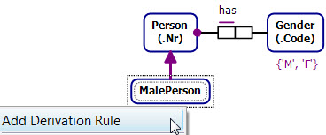

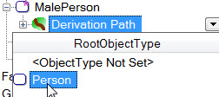

Double click <Person> is of Gender to continue the path, then select the Gender role from this fact type occurrence.

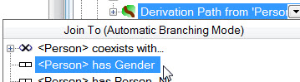

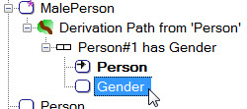

⇨

We wish to restrict the value of Gender (strictly, the character string representing Gender Code) to ‘M’. There are two ways to do this. By far the easiest way is to add a *value range condition* to this role to restrict it to ‘M’. This approach also ensures that the value ranges entered are type checked. With the gender role selected, enter M (without quotes) in the ValueRangeCondition field of the Properties window. NORMA redisplays this as “{‘M’}”, using the usual notation for displaying value constraints. You can think of this as a role value constraint applied only within the context of the rule. NORMA also internally assigns the variable Gender#1 to the Gender referenced in the rule.

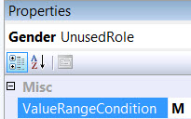

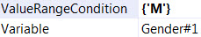

⇨

That completes the derivation path entry. Norma displays the condition “Gender in {‘M’}” on the Gender role occurrence, as shown. In displaying the Person has Gender fact type occurrence, NORMA appends “#1” to “Person” and “Gender”, because these Person#1 and Gender#1 variables correspond to role occurrences that are now included in the derivation path.

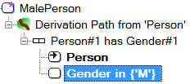

Now select the Person shape on the diagram, and ensure that its IsPersonal property is set to True, so that “**who**” will be used instead of “**that**” for its personal pronoun when verbalizing.

Now select the MalePerson shape on the diagram, and view the verbalization of the derivation rule in the verbalization Browser.



To display the derivation rule on the diagram, first copy its verbalization to the clipboard by selecting the rule text and pressing Ctrl+C. Then drag a Model Note icon from the Toolbox to the document window, open the Notes Editor and press Ctrl+V to paste the text into the Notes Editor, then hit Backspace at the end of the note to remove the extra line-break.

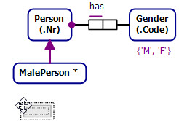



The derivation rule now appears in the model note on the diagram. If you wish, you may connect the note to the subtype shape using the Model Note Connector in the Toolbox.

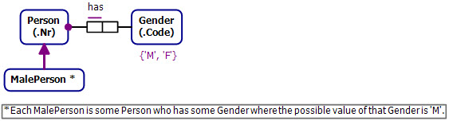

If you prefer the FORML version of the derivation rule, edit the model note to display it that way, as shown below. This editing of the model note has no impact on the derivation path or the way the rule is displayed when verbalized.

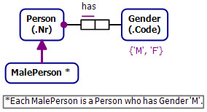

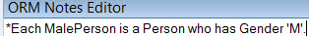

⇨

An alternative but longer way to add the gender restriction in the derivation path is to specify a calculation involving the equality. This alternative, more awkward approach is now discussed. Feel free to skip this alternative and go immediately to the next section, as the calculation-based approach is discussed in depth later for cases where it is really needed.

If you want to try this now on the model above, first remove the value range condition by selecting the Gender variable in the Properties window and deleting the “{‘M’}” entry.

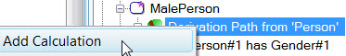Then right-click “Derivation Path from ‘Person’” and choose Add Calculation.

Then choose the “=”operator from the Function drop-down list. You are prompted to enter the left operand. Press the drop-down arrow to open the Data Source window to choose the source input for the operand. The Path Variables option displays object variables available in the derivation path, Calculated Values displays previous calculations (if any), and the Constant Value option allows you to enter a constant value.

Expand Path Variables, and select the Gender#1 variable as shown. Hovering the mouse over the “?” icon displays further information in a tooltip that shows the object variable in angle brackets within its fact type occurrence[7].

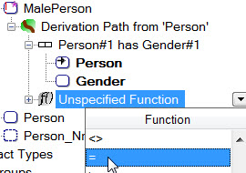

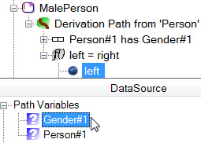

⇨

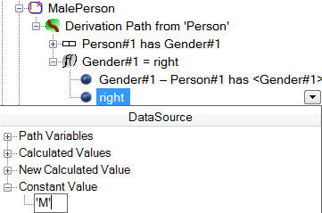For the right operand of the equality, press the drop-down arrow, expand Constant Value in the Data Source window, and enter ‘M’ as shown.

Currently, NORMA does not type check constants that you enter here, so you could omit the single quotes in ‘M’. However, it is best to include the quotes, and a future version of NORMA will add type checking for such constants.

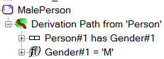

NORMA displays the calculation as “Gender#1 = ‘M’”, as shown.

Calculations within derivation paths may be used as *path conditions* (i.e. conditions to be satisfied), derivation path inputs to other calculations, or as projection sources. In this case, the restriction on gender code is a path condition. To indicate this, select the function expression Gender#1 = ‘M’, and then in the Properties window toggle its PathCondition setting to True by double-clicking the False entry.

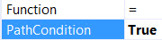

 ⇨

That completes the derivation path entry. As you can see, this way of entering a comparison to a constant value as a calculation is much harder than simply applying a value range condition. This is even more the case for complex value range conditions, as we’ll see later. The verbalization generated from this alternative approach is shown below. This differs from the verbalization for the first approach by using the equality operator “=” to specify the value restriction.



## Derivation Rules with Other Value Comparisons



Figure ‑ Two subtypes involving value comparisons

The ORM schema in Figure 1‑6 includes Teenager and OverdrawnPerson as derived subtypes with their derivation rules expressed in FORML. The reference mode for Age is y (i.e. years), so the value range 13..19 y in the derivation rule for Teenager (**\*Each** Teenager **is a** Person **who** has Age **in** 13..19 y.) is understood to mean a duration of at least 13 and at most 19 years. The range end numbers (13 and 19) are included in the range, so this corresponds to a closed interval.

The derivation path for this rule may be entered in the Model Browser as follows. Right-click Teenager, select Add Derivation Rule from its context menu.

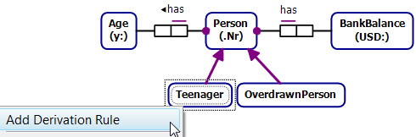

Now double-click Person to select it as the root object type. Then double-click <Person> has Age to continue the path.

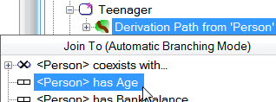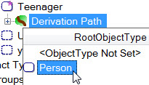

⇨

Select the Age variable, and in the Properties window enter the range 13..19 as its ValueRangeCondition.

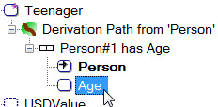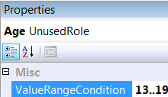

⇨

That completes the derivation path, which now displays as shown. The range condition displays as Age in {13..19}. Ensure the datatype for Age is set to a numeric type (e.g. unsigned small integer), otherwise you might see quotes around the numbers, meaning the datatype is string based.

This way of entering the derivation path is much faster than adding two calculations, one for Age ≥ 13 and one for Age ≤ 19. The verbalization of the derivation rule is as shown, assuming the IsPersonal property for Person is set to True.



Select the verbalization text, press Ctrl+C to copy it to the clipboard, then drag a Model Note icon from the Toolbox to the document window, open the Notes Editor and press Ctrl+V to paste the verbalization into the model note. Press Enter after “Age” to move the where-clause to the second line, and press Backspace at the end to remove the extra blank line.

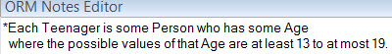

The derivation rule for Teenager is now displayed on the diagram as shown.

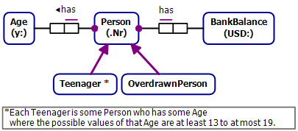

The subtype OverdrawnPerson is defined in FORML as: “**\*Each** OverdrawnPerson **is a** Person **who** has BankBalance < 0 USD.”. The USD reference mode for BankBalance indicates the currency unit is US dollars, so the condition BankBalance < 0 USD means a negative amount of money in US dollars (so the bank account is overdrawn).

The derivation path for this rule may be entered in the Model Browser as follows. Right-click OverdrawnPerson, select Add Derivation Rule from the context menu, then double-click Person to select it as the root object type.

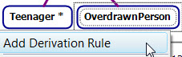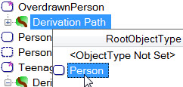

⇨

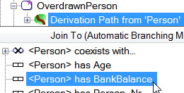Double-click <Person> has BankBalance to add this to the path.

Select the BankBalance variable, and in the Properties window enter the range “..0)” as its ValueRangeCondition. Be sure to include the closing parenthesis “)”, because this tells NORMA to exclude the 0 value, and hence “..0)” means “< 0”. By default, ranges in NORMA are assumed to be closed, so that end values are included unless you indicate otherwise by adding the parenthesis.

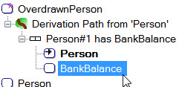

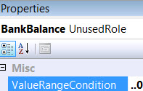

⇨

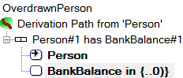That completes the derivation path, which displays as shown.

The verbalization is shown below.



Select the verbalization text, press Ctrl+C to copy it to the clipboard, then select the Model Note containing the Teenager rule, open the Notes Editor and press Ctrl+V to paste the verbalization into the bottom of the model note. Press Enter after “BankBalance” to move the where-clause to the second line.

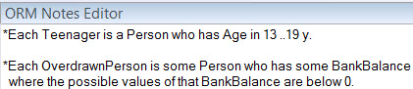

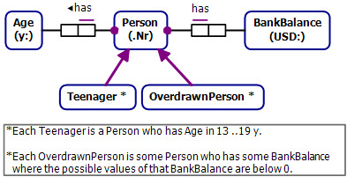In the document window, the two derivation rules are now displayed in the model note as shown.

While understandable, the verbalization of the rules (especially the second rule) is somewhat awkward. We plan to improve the verbalization in a later release, but if desired you can edit the model note to refine the derivation rules formulation (e.g. using FORML, as shown below). Again, editing the model note has no impact on the actual verbalization.

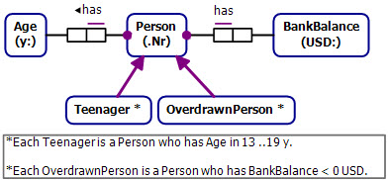

Alternatively, you could have entered the condition “BankBalance < 0” using a calculation involving the < function, but that would take longer.

## Derivation Rules involving Multiple Inheritance

In the ORM schema in Figure 1‑7, the subtype MaleSmoker is a subtype of both Smoker and MalePerson, so this is a case of *multiple inheritance*. The derivation rule for MaleSmoker is specified in FORML thus: “**\*Each** MaleSmoker **is a** Smoker **and a** MalePerson.”. Because the subtype is marked as fully derived, and this is the only derivation rule provided for it, the rule is interpreted strongly as a subtype definition. In other words, being a male person and a smoker is both necessary and sufficient for on object to be a male smoker. Hence, the type MaleSmoker is the intersection of Smoker and MalePerson (not just a subset of the intersection).



Figure ‑ The MaleSmoker subtype inherits from both Smoker and MalePerson

There are many correct ways to declare the derivation path. We first discuss one way that is probably the most intuitive. You can visualize the derivation path for this approach as shown in the diagram opposite.

Starting at Person as the root object type we apply a *conjunction* symbolized here using “**and**” for the logical conjunction operator, with two branches below it.

In ORM, a relationship between subtype and supertype implies an instance level identity relationship (verbalized with an “**is**” predicate) between instances of those types. Each branch of the conjunction navigates down an instance level identity relationship from an instance of Person to an instance of the relevant subtype (MalePerson or Smoker). The path involves a *conceptual join* between the Person roles shown here with gold fill (i.e. the same person plays both roles).

To enter the derivation path in the Model Browser, right-click MaleSmoker on the diagram and select Add Derivation Rule from its context menu.

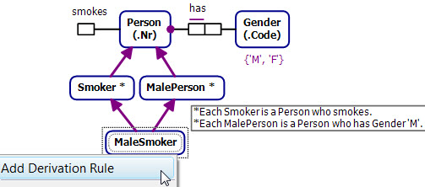

Now choose Person as the root object type, and then select the role played by Person in the instance-level identity relationship Person is Smoker. In the Model Browser, instance-level identity relationships are prepended by a subtyping arrow.

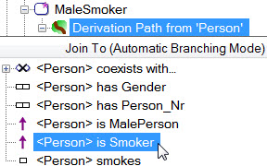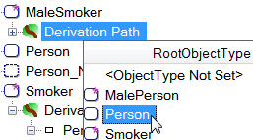

⇨

Now go up to the path header Derivation Path from ‘Person’, open its drop-down list, and select the role played by Person in the identity relationship Person is MalePerson.

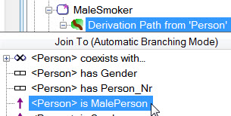

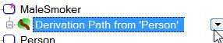

⇨

As shown on the left belowbelow, the derivation path is displayed as a conjunction of two branches (Branch 1 and Branch 2), each starting at Person. The “& And” at the top indicates the conjunction operator (in logic, an ampersand “&” is often used for the conjunction operator). *When branching from the root object type, NORMA automatically performs a conceptual join on the starting roles* (so they are *implicitly* *correlated*), and indicates this by appending the same number to the object type variables for the role occurrences. In this example, both variables are named Person#1. For comparison purposes, the explanatory path diagram shown earlier is repeated so you can easily see how the derivation path displayed in the Model Browser corresponds to an expression tree.

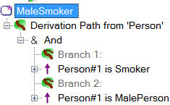

The derivation path for MaleSmoker is now complete. To view the automated verbalization of the derivation rule, select the MaleSmoker shape in the document window and open the Verbalization Browser.

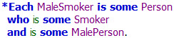

Select the verbalization, press Ctrl+C to copy it to the clipboard, select the model note in the document window, then press Ctrl+V to paste the rule into the model note in the Notes Editor. When you copy the verbalization, the indentation is lost, so it is helpful to insert some spaces to restore the indentation as shown. If the derivation path has multiple branches, the verbalizer currently uses indentation to group branches separately, so some meaning may be lost if you do not retain the indentation.

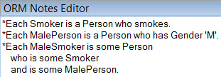

If you wish, refine the model note (e.g. by replacing “some” by ‘”a” and reformatting as desired). The derivation rules are now displayed in the model note on the diagram.

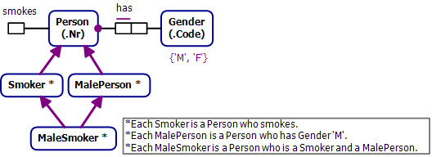

Another way to specify the derivation rule for MaleSmoker is to choose Smoker as the root object type, and then select the Person role from the identity relationship Person is MalePerson, as shown. NORMA understands that a male person is a person, so makes all the roles of Person available to Smoker.

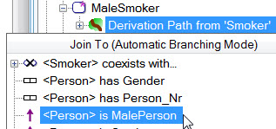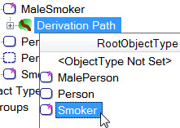

⇨

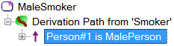You can visualize this path as starting at Smoker, moving up the subtyping connection to Person, and then moving down the subtyping connection to MalePerson. NORMA displays the final derivation path as shown[8].

Logical conjunction is commutative (i.e. given any propositions *p* and *q*, the conjunction *p* & *q* is equivalent to *q* & *p*). Hence, we could also have specified the derivation path by considering MalePerson before Smoker.

## Derivation Rules with Negation

The ORM schema in Figure 1‑8 includes three subtypes whose derivation rules involve negation, as indicated by the inclusion of “**not**” or “**no**” in their FORML definitions. We now discuss how to specify the derivation paths for these rules in NORMA, starting with the NonSmoker subtype, then considering NonDriver, and finally Teetotaller.



Figure ‑ The derivation rules for the three subtypes involve negation

The ORM schema minus the subtype derivations is shown below. To add the derivation path for NonDriver, right-click NonSmoker, and select Add Derivation Rule from its context menu.

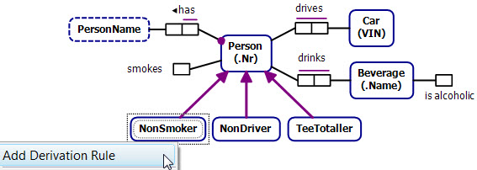

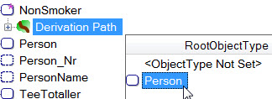In the Model Browser choose Person as the path root.

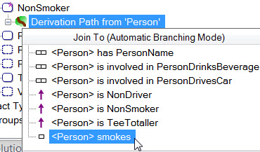

Now choose <Person> smokes from its drop-down list of fact roles.

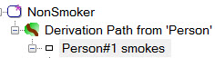At this stage, the derivation path is displayed as Person#1 smokes.

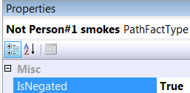

Select this and then toggle its *IsNegated property* from False (the default) to *True*. To toggle the truth value, either double-click it or open the drop-down list and select the other truth value. This negates the Person#1 smokes condition by applying a logical **not** operator to it.

That completes the derivation path, which is now displayed as shown on the left below. A “Not” operator precedes Person#1 smokes, and a tilde “~” (logical symbol for the *negation operator*) appears underneath the arrow in the icon that precedes the Person role in this fact type. The arrow in the icon simply indicates that this is the entry role into the fact type. You may visualize this path as shown on the right.

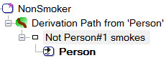

The derivation rule verbalizes thus:



Now let’s add a derivation path for NonDriver. The derivation rule for NonDriver is expressed in FORML as follows: **\*Each** NonDriver **is a** Person **who** drives **no** Car. This is equivalent to the following rule:

**\*Each** NonDriver **is a** Person

**where it is not the case that that** Person drives **a** Car.

You can think of this rule as specifying a derivation path that starts at Person, continues the path through the drives predicate to Car, and then negates the predicate by inserting the negation operator “**not**” before the drives role. You can visualize this path as shown opposite. In logic, the negation operator may be verbalized as “it is not the case that”.

To add the derivation path for NonDriver in the Model Browser, first add the path for Person drives Car as shown.

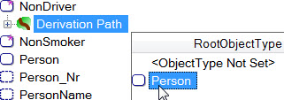

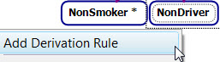

⇨

⇩

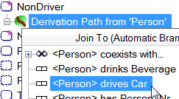

To negate the drives predicate, select Person drives Car, and then in the Properties window toggle the truth value of IsNegated to True.

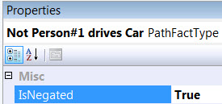

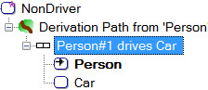

⇨

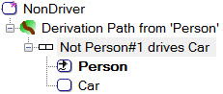The derivation path is now complete, and displays as shown.

The derivation rule verbalizes as shown below.



Now let’s consider the derivation rule for Teetotaller, which may be expressed in FORML as “**\*Each** Teetotaller **is a** Person **who** drinks **no** Beverage **that** is alcoholic.”. This is equivalent to the following:

**\*Each** Teetotaller **is a** Person

**where it is not the case that that** Person drinks **a** Beverage **that** is alcoholic.



You can think of the derivation path for this rule as starting at Person, continuing the path through the drinks predicate to Beverage, and then onto the is-alcoholic predicate (performing a conceptual join on Beverage as you pass through), and then negating the path below Person by inserting a **not** operator before the drinks role. You can visualize this path as shown opposite. The roles with gold fill are conceptually joined, so that the same beverage plays both roles. NORMA performs this join for you automatically when you extend the path to the is-alcoholic predicate.

To add the derivation path to NORMA, we first enter the unnegated path for Person drinks Beverage **that** is alcoholic, and then negate it. To add the unnegated path in the Model Browser, right-click Teetotaller and select Add Derivation Rule from its context menu. Then select Person as the root object type, and continue the path by selecting <Person> drinks Beverage.

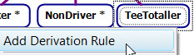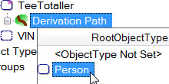

⇨

⇩

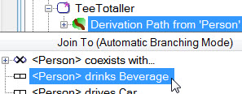

Now select the Beverage role in the drinks fact type, open its drop-down list, and select <Beverage> is alcoholic.

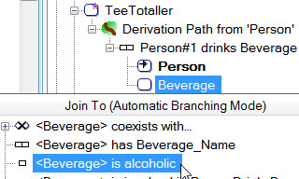

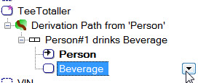

⇨

That completes the unnegated path. You can see that the Beverage roles are correlated (joined), because their object variables are displayed with the same suffix (Beverage#1).

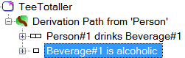

To negate the path below Person, select the first fact type in the path (Person#1 drinks Beverage#1), and in the Properties window toggle its IsNegated setting to True.

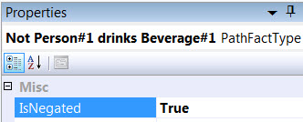

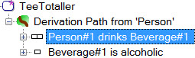

⇨

That completes the derivation path, which displays as shown.

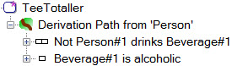

The rule verbalization may be viewed in the Verbalization Browser.

*Each TeeTotaller is some Person who drinks no Beverage that is alcoholic.

To display the derivation rules in the document window, copy and paste their verbalizations to a model note in the usual way. Be sure to select the model note shape immediately before pasting the verbalization text.

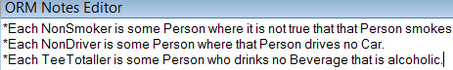

If desired, refine the model note to show the rules in a more compact form (e.g. as shown below). Again, this has no impact on the automated verbalization.

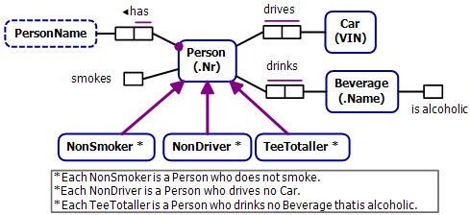

Ongoing development plans for NORMA include improvements to verbalization, so one or more of these compact forms might be generated automatically in a future release. The compact form of the third rule simply replaces “some” by “a”. The compact form of the second rule also replaces a where-clause by a relative clause. The compact form of the first rule requires deeper linguistic analysis because the predicate reading “smokes” is changed to “smoke” when negated by “does not”.

## Derivation Rules with Disjunction

The ORM schema in Figure 1‑9 includes two subtypes whose derivation rules involve a logical *disjunction*, as indicated by the use of the *inclusive-or operator* “**or**” operator in their FORML definitions. We now discuss how to specify the derivation paths for these rules in NORMA, starting with the Resident subtype.



Figure ‑ The derivation rules for the subtypes involve logical disjunction

The use of inclusive-or rather than exclusive-or in the FORML definition for Resident “**\*Each** Resident **is a** Person **who** is a resident citizen **or** is a resident alien.” is sufficient because the exclusive-or constraint in the schema enforces the exclusion.

You can think of the derivation path for this derivation rule as starting at Person, and continuing as a disjunction of two branches, with each branch containing one of the unary predicates. You can visualize this path as shown opposite.

To add the path in the Model Browser, we will first enter the path Person is a resident citizen, and then perform an *or-split* to add the second disjunct on another branch. Right-click Resident and select Add Derivation Rule from its context menu. Then select Person as the root object type, and continue the path by selecting the first disjunct <Person> is a resident citizen.

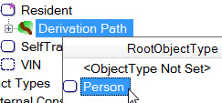

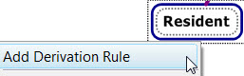

⇨

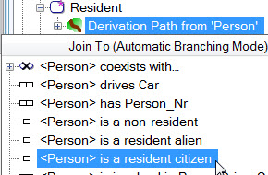

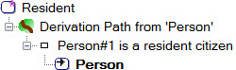

⇨

Now *move up to* Derivation Path from Person (not the Person role!), and open the drop-down list. By default, NORMA displays the Operator “And” below the list in preparation to perform a conceptual join.

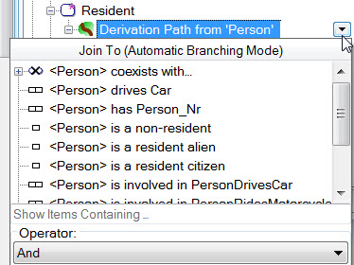

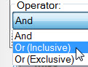However, rather than branching from an **and**-operator, we want to branch from an **or**-operator. To apply an or-split, click the Or (Inclusive) operator to select it instead of the And operator.

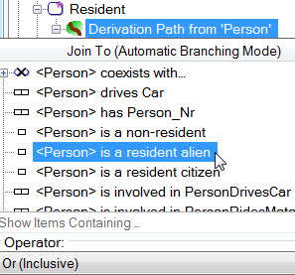To complete the derivation path, select the other disjunct <Person> is a resident alien.

NORMA displays the inclusive-or operator using both its logical symbol “∨” and its English reading “Or (Inclusive)”, with the two branches (Branch#1 and Branch#2) below it, as shown on the left below. You can tell the two Person variables are correlated because they are both named “Person#1”. For comparison purposes, the disjunctive path diagram shown earlier is displayed on the right. Branch#1 corresponds to the left-hand branch and Branch#2 to the right-hand branch.

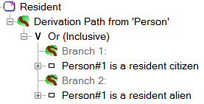

Assuming the IsPersonal property for Person is set to True, the derivation rule now verbalizes as shown:

*Each Resident is some Person

who is a resident citizen

or is a resident alien.

The SelfTransporter subtype is defined in FORML thus: “**\*Each** SelfTransporter **is a** Person **who** drives **a** Car **or** rides **a** Motorcycle.”. The derivation path may be visualized as shown opposite, and may be entered in a similar fashion to the example just discussed by entering an or-split for the two branches Person drives Car and Person rides Motorcycle. The derivation path and verbalization you should end up with are shown below.

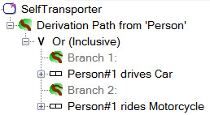

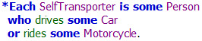

To display the derivation rules in the document window, copy and paste their verbalizations to a model note in the usual way. Be sure to select the model note shape immediately before pasting the verbalization text. The final result is shown next, after reformatting the model note with better indentation. If you wish, you can refine the model note further.

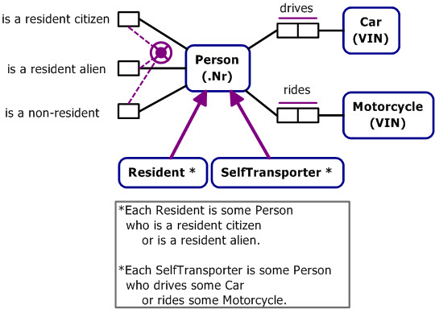

## Simplifying Subtype Navigation

In the ORM schema shown in Figure 1‑10, Manager is an asserted subtype of Employee, and FemaleManager is a derived subtype of Manager that uses a fact type of Employee in its definition. The derivation rule expressed in FORML specifies a derivation path that navigates along the subtyping connection from Manager to Employee, and then navigates from Employee to Gender, finally restricting the Gender value. This section shows how to save some work when entering the derivation rule by relating a subtype directly to a role of its supertype, relying on NORMA to implicitly provide the subtyping connection.



Figure ‑ The derivation path navigates from Manager to Employee to Gender

One way to enter the derivation rule in NORMA is to choose Manager as the root, and then select the subtyping connection <Employee> is Manager in order to navigate to Employee, and then select the Employee role, continue the path along the Employee is of Gender fact type, and then apply the value restriction ‘F’ to Gender.

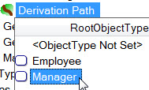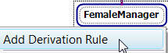

⇨

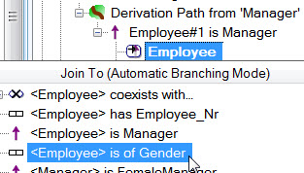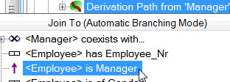

⇨

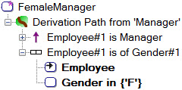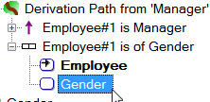

⇨



That completes the derivation rule. Ensure the IsPersonal property of Employee is set to True (this automatically sets the IsPersonal property of its subtypes to True as well). Select the FemaleManager subtype and open the Verbalization Browser to see the rather awkward rule verbalization shown below. Notice the redundant “**is of some** Manager **and** ”. The way the current verbalization works, this awkwardness was caused by explicitly including the subtyping link between Manager and Employee as part of the derivation path.



A quicker way to enter the rule is to ignore the explicit Manager-Employee subtyping linkage, instead choosing Employee is of Gender as your path continuation from the Manager root object type. Because you are joining from Manager, continuing the path from Employee implies the Manager-Employee identity assertion, so there is no need to explicitly state it. Finish the rule entry by restricting Gender to ‘F’.

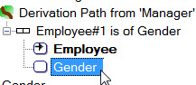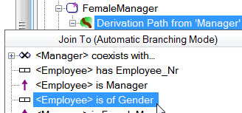

 ⇨

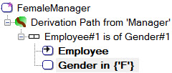This not only saves time but leads to a shorter display of the derivation path, as well as a more elegant verbalization with no redundancy (see opposite and below).



## Semiderived Subtypes

Recall that a subtype is *semiderived* if and only if some of its instances may be simply asserted and some other instances may be derived. Graphically, semiderived subtypes are displayed with a plus superscript “**+**” after their name. Figure 1‑11 shows an ORM schema discussed earlier in which Grandparent is semiderived subtype. If the relevant parenthood facts are known, a grandparenthood fact can be derived, but if not then the grandparent fact can be simply asserted. The FORML derivation rule shown here is prepended by “+” and also includes “**derived**” to indicate the semiderived status of the rule.



Figure ‑ In this ORM schema, Grandparent is a semiderived subtype

You can visualize the derivation path for this rule as shown opposite. Since the Person type appears multiple times, numbers are appended to the object type name to distinguish the object variables involved. Here we start with Person1 as the root, then navigate through the parenthood predicate to Person2 and then navigate again though the parenthood predicate to Person3, performing a conceptual join on the role occurrences played by Person2. In this diagram, the role occurrences being joined are highlighted with gold fill. In the FORML version of the derivation rule, the conceptual join is expressed by the second occurrence of “**who**”.

To add the derivation path for this rule, we’ll first specify the path in the usual way for a derived subtype, then later set the derivation status to semiderived. To begin, select Grandparent, choose Add Derivation Rule from its context menu, then select Person as the root of the derivation path.

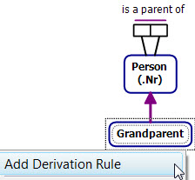

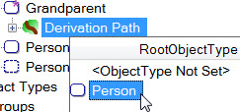

⇨

Now select <Person> is a parent of Person from the drop-down list. The derivation path is now displayed using Person#1 for the first object variable, and two occurrences of Person below it, one for each role in the parenthood predicate. Select the second instance of Person, and click the drop-down arrow to its right to open its drop-down list.

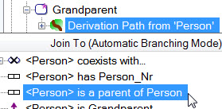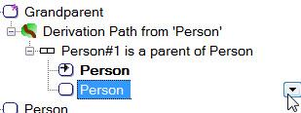

⇨

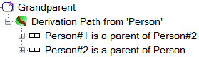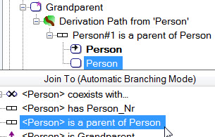Continue the path by selecting <Person> is a parent of Person. You can see that this applies a conceptual join, because the object variable for each of the join role occurrences is displayed as Person#2. The final object variable is simply named Person rather than Person3 because it is not used elsewhere in the rule, so there is no need to later refer to it (this corresponds to an anonymous variable in languages like datalog or Prolog). ⇩

To set the derivation status of the path to semiderived, select the Derivation Path from ‘Person’ header and toggle its Completeness property from Fully Derived (the default) to Partially Derived, by either double-clicking or selecting it from the drop-down list.

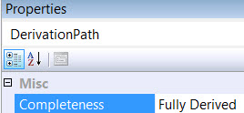

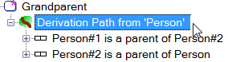

⇨

⇩



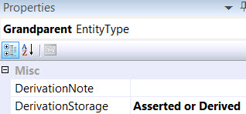Another way to set the derivation status of a subtype is to select the subtype and set its DerivationStorage property to Asserted or Derived as shown opposite. This property also allows you to choose to store the derived instances (by selecting the DerivationStorage option Asserted, or Derived and Stored).

That derivation rule is now verbalized as shown below, with a “**+**” sign and “**derived**” indicating the semiderived status of the rule. To display the rule on the diagram, copy and paste the verbalization to a model note in the usual way.

**+Each derived** Grandparent **is** **some** Person1

**who** is a parent of **some** Person2 **who** is a parent of **some** Person.

# Adding Fact Type Derivation Rules

## Introduction

In ORM, fact types may be asserted, derived, or semiderived. A fact type is *asserted* if and only if, for each state of the fact base, only asserted instances may appear in its population. A fact type is *derived* if and only if, for each state of the fact base, only derived instances may appear in its population. A fact type is *semiderived* if and only if some of its instances may be simply asserted and some other instances may be derived. Graphically, derived fact types are displayed with an asterisk “*” after their displayed predicate reading(s), and semiderived fact types are displayed with a plus superscript “**+**” after their displayed predicate reading(s).

Consider the ORM schema in Figure 2‑1. Here the fact types Person drives Car and Car is of CarModel are simply asserted. In contrast, the fact type Person drives CarModel is derived from the asserted fact types using the derivation rule shown. For example, if we know that a person drives a car that is an instance of a Ford car model then we may infer that that person drives a Ford. The derivation rule is expressed in FORML, using “**iff**” for “**if and only if**”.



Figure ‑ Here, the fact type Person drives CarModel is derived from two asserted fact types

Now consider the ORM schema in Figure 2‑2. Here the fact type Person drives CarModel is semiderived, as indicated by the “+” superscript and the use of the operator “**if**” instead of “**iff**” in the derivation rule. If we know that a specific car is driven by a person and we know the model of that car then we may infer that that person drives that car model. However, this schema also allows us to assert that a person drives a specific car model (e.g. Terry drives a Mazda) without knowing which specific car(s) of that model is/are driven by that person.



Figure ‑ Here, the fact type Person drives CarModel is semiderived

While one can declare that a fact type is derived simply by entering some text in the DerivationNote property for the fact type in the ORM Model Browser, derivation notes are treated by NORMA simply as informal comments, so no code will be generated from them to enforce the derivation rules. Currently, the only way to formally declare a derivation rule in NORMA is to specify a *derivation path* for it in the ORM Model Browser and then *project* on the relevant role occurrences (or sometimes calculations) in the path to return the derived result. The rest of this chapter discusses how to enter formal fact type derivation rules in NORMA.

*A fact type’s derivation path is the path through the ORM schema, including any operators, conditions or calculations that apply, from which the object variables in the derived or semiderived fact type may be projected*. The path usually starts at an object type, known as the *root object type* for the path. With complex paths, you might need to traverse through the same role more than once, in which case we need to distinguish different occurrences of the same role. When this is not the case, the term “role” is often used informally for “role occurrence”.

For the derived Person drives CarModel fact type in Figure 2‑1, the derivation path starts at Person (the root object type for the path) navigating through Person drives Car and then Car is of Carmodel, performing a conceptual join on Car (i.e. on the roles played by Car). You can visualize the derivation path as shown in Figure 2‑3, where the roles being joined are displayed with a gold fill color. The derivation is completed by projecting on the roles (colored light green and blue) played by Person and CarModel in the path, and binding the roles in the derived fact type to these projected roles. This final, role binding phase is not needed when declaring subtype derivation rules.



Figure ‑ Roles in the derived fact type are bound to the roles projected from the derivation path

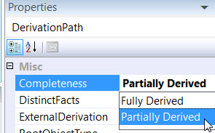For the semiderived Person drives CarModel fact type in Figure 2‑2, the derivation path and projection are the same as that for the fully derived fact type example just discussed. However, the Completeness property of the derivation path is set to Partially Derived instead of Fully Derived.

The remaining sections of this chapter discuss several examples of how to add derivation rules for derived and semiderived fact types using NORMA. The completed ORM schemas for these examples are available in the following NORMA files, listed by section number. You may work through the examples interactively with NORMA by first deleting the Derivation Path, and then following the step-by-step procedure outlined in the section for the relevant example.

To remove the derivation path for a subtype, right-click the fact type shape in the Document window, choose Select in Model Browser form its context menu, then select the Derivation Path header for that fact type in the Model Browser and press the delete key (or right-click the derivation path header and choose Delete From Model).

|  |  |
| --- | --- |
| *Section* | *NORMA file* |
| 2.2  2.3  2.4  2.5  2.6  2.7  2.8  2.9  2.10  2.11  2.12  2.13  2.14 | Derivation11_LivesIn.orm  Derivation12_CommunicatesIn.orm  Derivation13_AncestorOf.orm  Derivation14_Subtotal.orm  Derivation15_TotalPrice.orm  Derivation16_TotalSalesRevenue.orm  Derivation17_TypicalSportsperson.orm  Derivation18_TypicalSportsperson2.orm  Derivation19_StudentRatings.orm  Derivation20_StudentRatings2.orm  Derivation21_PersonPairs.orm  Derivation22_EmployeeName.orm  Derivation23_EmployeeName2.orm  Derivation24_CarmodelSales.orm  Derivation25_LivesIn2.orm  Derivation26_DrivesExpensiveCarmodel.orm |

## Projecting from a Linear Path

A derivation path that starts at a root object type and navigates through one or more fact types without branching is said to be a *linear path*. The derivation path for Person drives CarModel discussed in the previous section is one example of a linear path. Another example of a linear path is the derivation path for the derived Person lives in Country fact type shown in Figure 2‑4, which navigates through Person lives in State and then State is in Country.



Figure ‑ The derivation path from Person through State to Country is linear

Here, the fact type Person lives in Country is derived using the following FORML derivation rule: *Person lives in Country **iff** Person lives in **a** State **that** is in Country. The derived fact type is stated in the *head of the rule*, before the “**iff**” (“if and only if”) operator. The derivation path is stated in the *body of the rule* that appears after this operator. Object variables (here Person and Country) in the head of a FORML derivation rule are understood to be universally quantified, so the rule formulation is understood to abbreviate the following expanded formulation:

**\*For each** Person **and** Country,

(Person lives in Country **iff**

Person lives in **a** State **that** is in Country).

The “**iff**” operator has lowest priority, so is treated as the main operator in the scope of the quantification[9]. Here the pronoun “**that**” performs a conceptual inner join on the path roles played by State, so the state lived in by the person is the same state that is in the country. The rule may be verbalized in even longer form as follows, adding further “**that**” pronouns to emphasize the correlation back to earlier object variables:

**\*For each** Person **and** Country,

(**that** Person lives in **that** Country **iff**

**that** Person lives in **a** State **that** is in **that** Country).

The derivation path is a linear path from Person through the fact type Person lives in Stat, ending in the fact type State is in Country, as shown on the left of the diagram opposite. In passing through State, a conceptual join is performed between its entry and exit roles (shown here with gold fill) to ensure the same State plays both role occurrences. The derived fact type is shown on the right of the diagram. *To complete the derivation rule, the roles of the derived fact type are bound to (matched with) role occurrences (or in some cases, calculations or constants) in the derivation path*. In this example, the Person and Country roles of the derived fact type are bound to the Person and Country roles projected from the derivation path (shown here with matching color fills).

To add the derivation rule to NORMA, we need to first add the derivation path and then bind the derived roles. Right-click the derived fact type Person lives in Country, select Add Derivation Rule from its context menu, and select Person as the root object type.

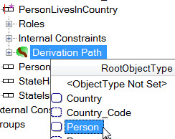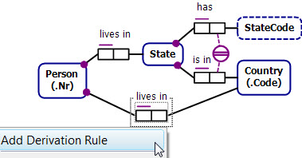

⇨

Continue the path by selecting <Person> lives in State, then select the State role of this fact type, and open its drop-down list.

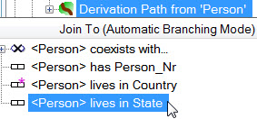

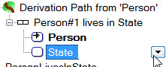

⇨

Complete the path by selecting <State> is in Country. You can tell that the State roles are correlated because they are both assigned the same object variable (State#1).

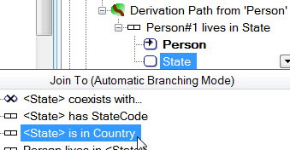

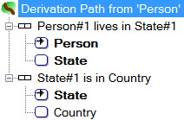

⇨

If we were entering a subtype definition, we would be finished. However, the derived fact type is still in an error state, as indicated by the red exclamation mark on it in the Model Browser (see opposite), and the red line fill around it in the Drawing window (see below). Right-click to show the context menu, then choose Validation Errors to see the error message. Since we are entering a derivation rule for a fact type, there is still one more thing to do: we must bind the roles in the derived fact type to the relevant items (in this case, the Person#1 and Country variables) in the derivation path. In other words, we must *project* the derived variables from the relevant roles in the join path (cf. relational projection).

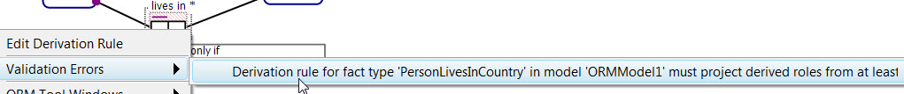

To do this, we choose the relevant roles as *derivation sources* in the Properties window for the Derivation Path. If you click the Validation Error message, this will take you to the property for the first derivation source, i.e. DerivationScource1 (Person). In general, double-clicking an error message often takes you to the next step needed to fix the error. Alternatively, select the Derivation Path from ‘Person’ header in the Model Browser, then select this derivation source property. The Derivation Source property has three options (Path Variables, Calculated Values, Constant Value). To access the available roles in the derivation path, expand the Path Variables option. Select the Person#1 variable. The Person role in the derived fact type is now bound to the Person#1 variable in the derivation path. If the fact type in which this role occurs is not fully displayed, you can view it in a Tooltip by hovering the mouse over the “?” icon that precedes the role. Although your role binding choice is not displayed in the Model Browser, it is displayed in the DerivationSource property when the derived Person role is selected.

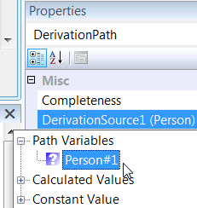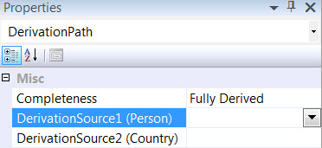

⇨

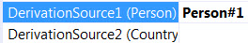 ⇩

Now open the drop-down list for DerivationSource2 (Country), expand Path Variables, and select the Country variable. The derived Country role is now bound to this Country role from the derivation path. NORMA appends a suffix to the role display (Country#1) indicating it is now used in the path[10].

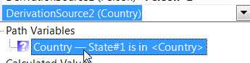

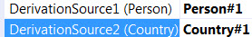

⇨

An alternative, but longer way to project the derived roles is to expand the Roles of PersonLivesInCountry, select the Person role, then in the Properties window open the drop-down list for Derivation Source (as shown below), then do the same for the Country role.

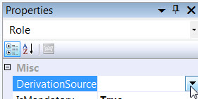

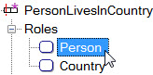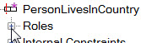

⇨ ⇨

That completes the derivation rule, which now displays with no error in the Model Browser. To suppress display of the roles in the derivation path, click the “−” buttons preceding their fact type display. As indicated earlier, to see the role bindings, select the derived roles and view their Derivation Source property in the Properties window (shown on the right below).

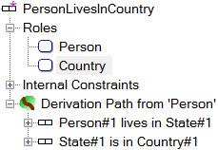





You can view the verbalization of the derivation rule in the Verbalization Browser.

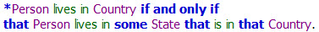

Copy and paste this text to a Model Note to display the rule in the document window.

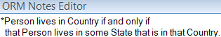

The final result is shown.

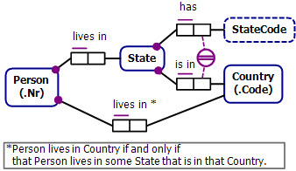

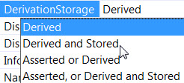By default, derived fact types in NORMA are evaluated lazily, so their fact instances are derived only on request, and are not stored. If you instead wish a derived fact type to be implemented as a materialized view, select the derived fact type and change its DerivationStorage property setting from Derived to Derived and Stored. The final two DerivationStorage options are available for semiderived fact types.

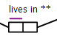

If you choose Derived and Stored, the derived fact type displays with a double asterisk “**” instead of a single asterisk.

An alternative way to change the derivation storage option is to select the Derivation Path from ‘Person’ header in the Model Browser, and choose the relevant option for Completeness (Fully Derived, Partially Derived) and for Storage (Not Stored, Stored).

## Correlating Path Variables

When you grow multiple branches from the same root object type, the same variable is automatically used for the root of each branch, since the role occurrences played by the root are considered to be implicitly joined. Similarly, when you extend a path by traversing through an object type, the entry and exit role occurrences played by that object type are implicitly joined, so are assigned the same path variable.

If you wish to *correlate* other role occurrences, you usually need to do this explicitly, to ensure that each is assigned the same path variable. In this section, we’ll consider two simple examples of this, one involving conjunction and the other disjunction, based on the ORM schema in Figure 2‑5. The following section on recursive rules provides another example of variable correlation.

Given the asserted fact types Person can speak Language and Person can write in Language, we can derive the two other fact types using the derivation rules shown.



Figure ‑ The derivation rules correlate Person variables and also correlate Language variables

The derivation rule for Person can fully communicate in Language may be expressed in FORML thus: *Person can fully communicate in Language **iff that** Person can speak **that** Language **and** can write **that** Language. Here we need to correlate the person variables in both conjuncts, and also correlate the language variables.

In entering the derivation path, the correlation of person roles is done automatically because Person is the root, but the correlation of the language variable will be done explicitly. Let’s see how to do this now.

Right-click the derived fact type, choose Add Derivation Rule from its context menu, then select Person as the root object type.

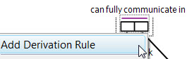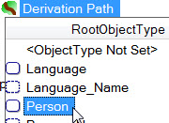

⇨

Select Person can speak Language, then select Person go back to Derivation Path from ‘Person’, open the drop-down list and select Person can write in Language.

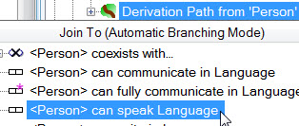

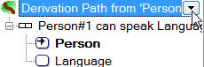

⇨

⇩

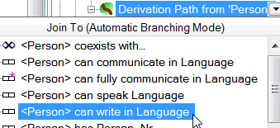

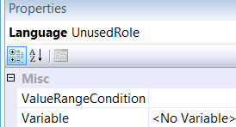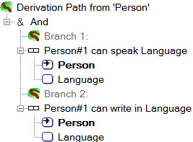The derivation path now appears as a conjunction with two branches as shown. The root (Person) variables have been automatically correlated, as shown by both being named Person#1. However, the Language occurrences are currently uncorrelated, which you can see by the lack of a numbered variable for them. Since it is not used elsewhere in the path, each “Language” role remains unbolded, and its variable property displays as “<No Variable>” (this corresponds to an anonymous variable). So it is possible that the language spoken might differ from the language written.

For this rule however, we want to ensure that the same language is both spoken and written by the relevant person. To do this, we must explicitly *correlate* (*equate*) the two Language role occurrences. To do this, select one Language role occurrence, open the drop-down list of its Variable property, and select the other Language role occurrence. The screen shot shown below first selects the language spoken role then sets its variable to that of the language written role. This correlates the two Language role occurrences so each is assigned the same variable, depicted as Language#1[11].

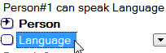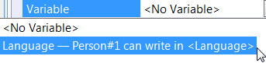

⇨

 ⇩

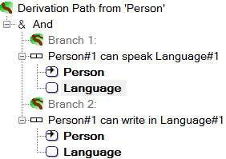The common Language#1 variable now appears in the derivation path, and both Language role occurrences are bolded, indicating they are used elsewhere, rather than simply being existentially quantified (equivalently, the two anonymous variables for Language are replaced by the same, named variable).

To complete the derivation rule, select the Derivation Path from ‘Person’ header, then in the Properties window select its DerivationSource1 (Person) property, open its drop-down, expand Path Variables, and select Person#1. Similarly, bind DerivationSource2 (Language) to the path variable Language#1.

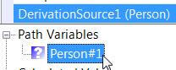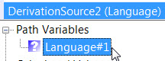

Select the derived fact type and open the Verbalization Browser to see the rule verbalization.

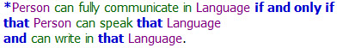

Now copy and paste the verbalization text to a model note so that the derivation rule is displayed with the ORM diagram, as shown below.

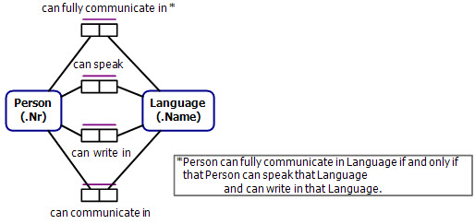

The other derivation rule for language communication expressed in FORML below involves an inclusive disjunction:

*Person can communicate in Language **iff**

**that** Person can speak **that** Language **or** can write in **that** Language.

This rule may be entered in a similar way to the previous one, the crucial difference being the choice of the Or (inclusive) operator when branching to the second disjunct after first pathing to Person can speak Language, as shown below.

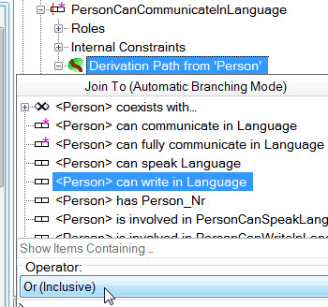

The final derivation path and verbalization appear as shown below.

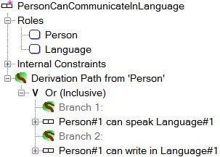





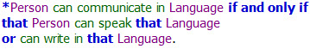

Now copy and paste the verbalization text to the bottom of the model note so that both the derivation rules are displayed with the ORM diagram, as shown below.

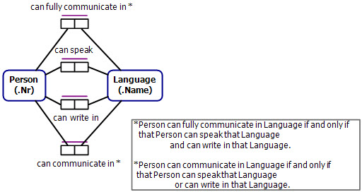

## Recursive Rules

The ORM schema in Figure 2‑6 includes a classic example where ancestry facts are derived using a *recursive derivation rule*, which is expressed inFORML as follows:

** Person1 is an ancestor of Person2 **iff**

Person1 is a parent of Person2

**or**

Person1 is a parent of **some** Person3 **who** is an ancestor of Person2.

Subscripts are appended to distinguish different variables based on the same object type[12]. The rule body is a disjunction of two clauses. The first disjunct (Person1 is a parent of Person2) is the *basis clause*, an asserted fact type. The second disjunct (Person1 is a parent of **some** Person3 **who** is an ancestor of Person2) is a *recursive clause*, since here the derived ancesterhood predicate is calling itself, but at a level closer to the parenthood basis, so after a finite number of such calls we will bottom out at the basis clause. So rather than arguing in a circle, recursion spirals into the basis and then unwinds itself, so everything works OK−a beautiful concept!

In this case, we’ve chosen to implement the derived fact type as a materialized view, so it’s both derived and stored (as shown by the double asterisk).



Figure ‑ The derivation rule for ancestorhood is recursive

You can visualize the derivation path as shown opposite, using subscripts as in FORML. Starting at Person1 as the root object variable, we have an **or**-split with two branches. The left-branch uses an asserted parenthood relationship to provide the basis clause. The right-branch starts with a parenthood relationship from Person1 to Person3, then continues with an ancestor relationship from Person3 to Person2, to provide the recursive clause. As you navigate through Person3, the entry and exit roles (shown with gold fill) of Person3 are correlated (conceptual inner join), so the person playing the child role in the input parenthood relationship is the same person who plays the ancestor role in the output relationship that follows.

Although the nodes named Person2 are shown separately, both these nodes denote the same object variable (since they have the same subscripted name). When we enter in NORMA the derivation path that corresponds to this diagram, we will need to explicitly correlate these two nodes, and only at that point will NORMA display them with the same suffix (corresponding to an object variable subscript in FORML).

To add the derivation path, right-click the ancestor fact type, chose Add Derivation Rule from its context menu, and then select Person as the root object type.

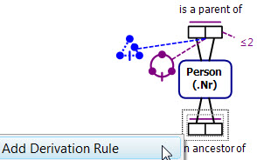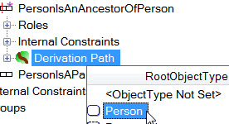

⇨

Now enter the basis clause by selecting <Person> is a parent of Person. NORMA renames the object variable for the first role as Person#1.

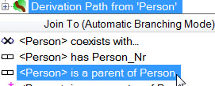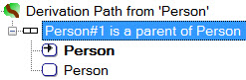

⇨

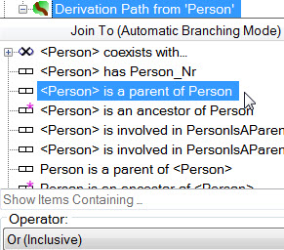

Move the cursor up to the Derivation Path header, open the drop-down list, select the inclusive Or operator, and then select <Person> is a parent of Person to start the second disjunct.

NORMA displays the path with an **or**-split into two branches, and displays a parenthood fact type on each branch. Because this split was performed at the root object type, the Person roles starting each branch are correlated (based on the same object type variable) as shown by each being assigned the same suffix (Person#1). Continue the second branch by selecting its second Person role, opening its drop-down list, and selecting <Person> is an ancestor of Person.

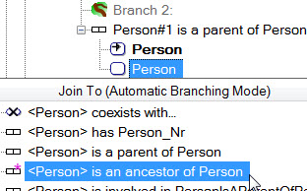

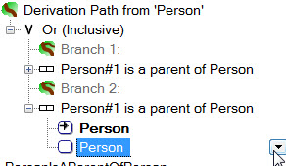

⇨

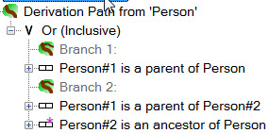NORMA displays the current path as shown opposite. Notice that the final Person roles in the fact types in both branches are not subscripted (Person), indicating that these roles are uncorrelated. We need to explicitly correlate these roles so that they are based on the same object variable.

Select the final Person role in either branch (I chose Branch 1), then in the Properties window go to Variable, open its drop-down list, and select the final person role in the other branch.

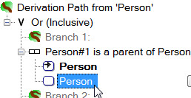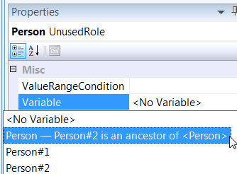

⇨

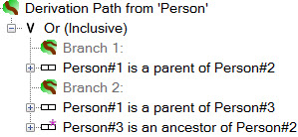The final roles on each branch are now correlated, as seen by NORMA naming each the same (Person#2). In so doing, NORMA renumbered the variable for the join roles to Person#3.

At this stage we have completed the derivation path, but we still need to bind the elements of the derived fact to the relevant elements of the derivation path. This example is somewhat complex because, unlike the previous case, we can’t just match derived roles to path roles.

You can visualize the binding process as shown opposite. For explanatory purposes, the Person2 variable is now shown only once in the derivation path. Each role occurrence is played by exactly one object variable (Person1, Person2, or Person3), but the same object variable may have many role occurrences playing it. As shown in the diagram, the binding is best understood as *matching object variables in the derived fact type to object variables in the derivation path*.

Recall the following FORML version of the derivation rule. Clearly we need to match the Person1 and Person2 object variables in the derived fact type with the Person1 and Person2 object variables in the derivation path (from a logic perspective, this means they are bound to the same quantifier, as shown in the previous footnote).

**Person1 is an ancestor of Person2 **iff**

Person1 is a parent of Person2

**or**

Person1 is a parent of **some** Person3 **who** is an ancestor of Person2.

Selecting the roles in the derived fact type is equivalent to selecting their object variables. In this example, selecting roles displayed as Person#1 and Person#2 in the derivation path is equivalent to selecting their object variables Person1 and Person2 (the disjunction of Person#1 roles is played by Person1, and both Person#2 roles are based on the object variable Person2).

To perform the binding from the derived fact type to the derivation path, select the Derivation Path header in the Model Browser, open the drop-down for its DerivationSource1 (Person) property, expand Path Variables, and select Person#1.

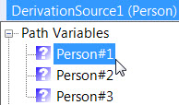

 ⇨

If you hover the cursor over the “?” icon, you’ll see a ToolTip letting you know this choice corresponds to an object variable playing the disjunction of the start roles in each branch.

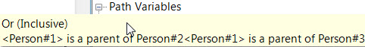

Similarly, bind DerivationSource2 (Person) to the Path Variable Person#2.

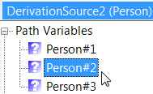

 ⇨

The rule verbalization is viewable in the Verbalization Browser, as shown below.

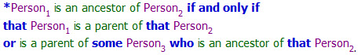

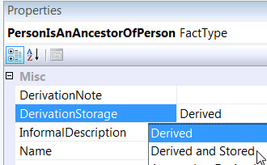To change the derivation status to derived and stored, select the derived fact type in the Model Browser, and then change its DerivationStorage Property to Derived and Stored. This causes the predicate reading for the derivedfact type to display with a double asterisk “**” on the ORM diagram.

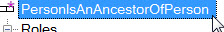

⇨

⇩



Finally, copy and paste the verbalization text into a model note to display the derivation rule on the diagram.

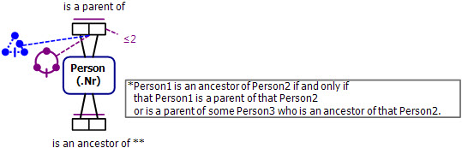

## Simple Calculations



Figure ‑ The derivation rule for subtotal involves a simple calculation

The ORM schema in Figure 2‑7 includes a derived fact type to calculate subtotals of line items. The derivation rule is specified in FORML, this time using role names to provide an attribute-style formulation. Using “*” for the multiplication operator, the LineItem subtotal rule is specified in FORML as follows:

**\*For each** LineItem,

subtotal = quantity * unitPrice.

Attribute-style formulations are often more compact and readable than their equivalent relational-style formulations, which use predicate readings. Although NORMA does not yet generate attribute-style verbalizations, support for this feature is planned for a future release.



We can picture the associated derivation path as shown opposite. Starting at LineItem as the root object type, we **and**-split into two branches, one using the fact type LineItem has Quantity and the other using the fact type LineItem has UnitPrice. To the derivation path (which can be identified with its root object type), we add a calculation that applies a multiply operator “*” to the quantity and unitPrice roles in the path.

The diagram also shows one way to visualize the binding from the derived fact type to the derivation path. The derived LineItem object variable (or equivalently, the derived lineItem role) is matched with the root LineItem variable in the derivation path. Since this variable plays both the start roles of the quantity and unit-price fact types, you can also think of this as binding the derived lineItem role to either of the starting roles played by LineItem in the derivation path. Finally, the derived subtotal price is bound to the result of the multiplication calculation in the derivation path.

In NORMA, *the multiply operator is treated as a* *function* with two arguments (its left and right *operands*). In entering the function, we’ll be prompted to enter its left and right multiplicands, and we’ll choose the path variables for the quantity and unit-price values.

Let’s now add the derivation path for the subtotal rule. Right-click the subtotal fact type, select Add Derivation Rule, then select LineItem as the root type and select <LineItem> has Quantity.

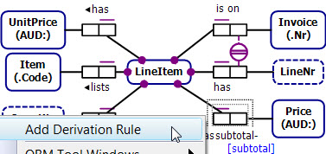

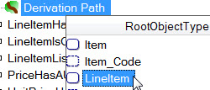

⇨

⇩

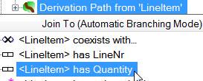

We want to branch from LineItem to the unit price fact type. So go up to Derivation Path from LineItem, open its drop-down list, and select <LineItem> has UnitPrice.

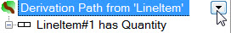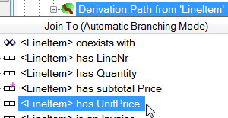

⇨

NORMA displays an **and**-split with the two branches as shown. The LineItem roles are implicitly correlated (both are named LineItem#1) because we branched from the root. To add the calculation to the path, right-click Derivation Path from LineItem, and select Add Calculation from its context menu.

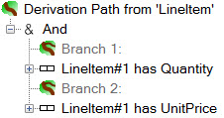

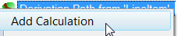

⇨

Now select multiply (**\***) as the function, and when prompted for the left operand, expand Path Variables in the Data Source and select the Quantity variable as shown. If you hover over the “?” icon, a tootip shows the fact type context for the variable.

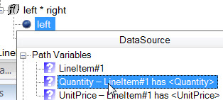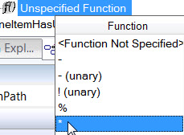

⇨

Similarly, select the UnitPrice role for the right operand. That completes the derivation path, which should appear as shown. The variables are displayed with a “#1” suffix because they are used in the path.

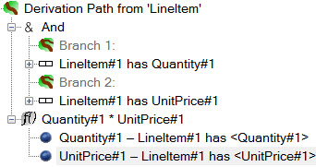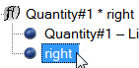

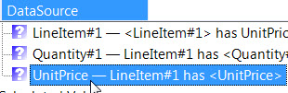

⇨

We now need to bind the derived fact type roles to the LineItem and calculation in the derivation path. In the Model Browser, select the Derivation Path from ‘LineItem’ header, then open the dropdown for its DerivationSource1 (LineItem) property, expand Path Variables and select LineItem#1. Now open the dropdown for the DerivationSource2 (Price) property, expand Calculated Values and select Quantity#1 * UnitPrice#1.

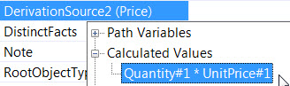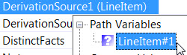

That completes the derivation rule for subtotals. The Model Browser displays the derivation path as shown on the left below. To see the role bindings, select the derived roles and view their Derivation Sources in the Properties window.

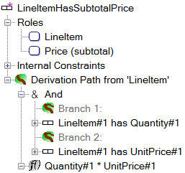





To see the verbalization of the derivation rule, select the derived fact type and open the Verbalization Browser.

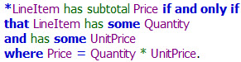

The rule verbalization is in relational style. You can copy and paste it into a Model Note to display the rule on the ORM diagram.

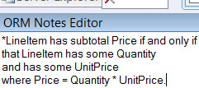

If you prefer the FORML attribute-style formulation of the rule shown earlier, then enter that manually in a model note as shown below.

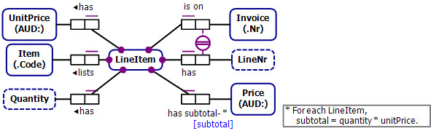

## Aggregate Functions

The ORM schema in Figure 2‑8 extends the example from the previous section by adding a derived fact type to compute the total price of an invoice, by summing the subtotal prices for that invoice. The FORML derivation rule is specified in attribute style thus: **\*For each** Invoice, total = **sum**(subtotal **of** lineItem).This may also be rendered in dot notation thus: **\*For each** Invoice, total = **sum**(lineItem.subtotal).



Figure ‑ The derivation rule for total price of an invoice involves an aggregate function

We can picture the associated derivation path as shown opposite. For explanation purposes, the ORM constraints are also displayed. Starting at Invoice as the root object type, we navigate to LineItem via the fact type LineItem in on Invoice. It doesn’t matter that there is no predicate reading directed from Invoice to LineItem. We continue the path from LineItem to Price, using the derived fact type LineItem has subtotal- Price. In passing through LineItem, a conceptual join is performed between its roles (shown here with gold fill). To the derivation path we add a calculation that applies a **sum** function to the prices populating the subtotal role for line items of that invoice.

The scope of the sum function is the root object type, Invoice (you’ll need to explicitly declare this later by indicating the aggregation context for the sum function). As you can see from the uniqueness constraint pattern, a single invoice may have many line items, so the sum function adds the subtotals for all the line items in the invoice. The **sum** function is an example of an *aggregate function* since, for each invoice, it applies to the *bag* (or *multiset*) of subtotal prices for line items on that invoice.

To complete the derivation rule, the invoice and total price roles in the derived fact type are bound to the derivation path’s invoice role and the result of the sum calculation respectively.

Let’s now add the derivation path for the invoice total price rule. To begin, right-click the invoice total price fact type, select Add Derivation Rule, then select Invoice as the root object type, and select LineItem is on <Invoice>. Even though no predicate reading is provided from Invoice to LineItem, we can still navigate in this direction by adding this fact type to the path.

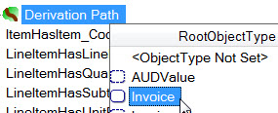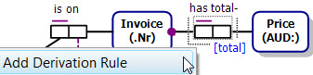

⇨

⇩

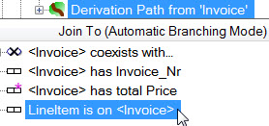

To continue the path through LineItem, select the LineItem role, open its drop-down list, and select <LineItem> has subtotal Price.

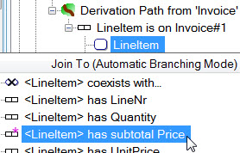

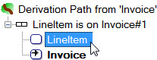

⇨

⇩

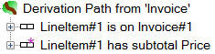

To add the sum calculation, right-click Derivation Path from ‘Invoice’, select Add Calculation from the context menu, select sum from the Function list, then in the DataSource property expand Path Variables and select the subtotal Price role.

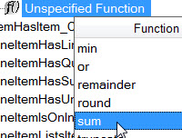

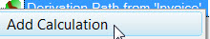

⇨

⇩

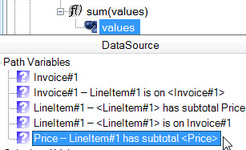

To bind the derived roles to the relevant path elements, select the Derivation Path from ‘Invoice’ header, open the dropdown for the DerivationSource1 (Invoice) property, expand Path Variables and select Invoice#1.

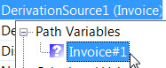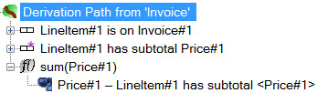

⇨

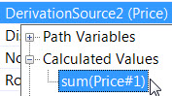Now open the dropdown for the DerivationSource2 (Price) property, expand Calculated Values and select sum(Price#1).

At this point, the scope of the sum function is ambiguous. It could be Invoice (returning a sum *for each* Invoice, which is what we want), but also could be unrestricted (returning just one sum totalled over all invoices) or LineItem (returning a sum for each line item). To ensure that the sum function is applied for each invoice, we need to set the function’s *aggregation context* to Invoice. In SQL terms, the function result is said to be *grouped by* Invoice, and the aggregation context is called the *group-by criterion* (or criteria if there are more than one). To declare this, select the function expression sum(Price#1), and then in the Properties window, for AggregationContext select the check box for Invoice #1.

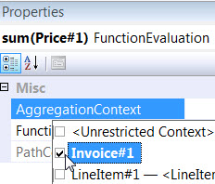

 ⇨

That completes the derivation rule, which is displayed as shown on the left below. To see the derivation sources, select each derived role and view its DerivationSource property. To see the grouping criterion for the sum function, select the function and view its AggregationContext property.

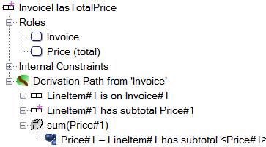







To view the verbalization of the derivation rule, select the rule and open the Verbalization Browser.

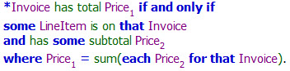

If you wish to display this relational style verbalization on the ORM diagram, copy and paste it into the Model Note. If you instead wish to display the FORML version given earlier, manually append it to the Model Note, as shown below.

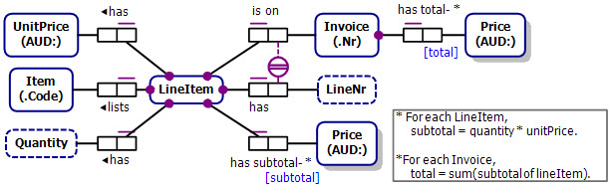

## Nested Calculations

In the previous section, the invoice total price derivation used two rules, with one rule to first derive line item subtotals and a second rule to sum these subtotals. However, in the schema of Figure 2‑9 the invoice total price is computed with just a single rule, by nesting one calculation (quantity * unitPrice) inside another (sum). The schema also includes a fact type to derive the total sales revenue of each sale item.

Notice that each of the derivation rules includes a line item subtotal computation within it. If we define a line item subtotal rule first (as we did in the previous section), we can reuse this rule in defining both of the total rules above in a simpler form. Hence for this application it would be better to compute the subtotal in a separate rule rather than nesting it inside other rules as shown below.



Figure ‑ Each derivation rule involves a calculation with a calculation

However, nested calculations are sometimes quite useful, and this section discusses how to add the derivation rule for invoice totals with the subtotal calculation nested inside the rule. The entry of the item revenue rule is similar so is omitted, but may be used for extra practice. The invoice total price rule may be specified as a single derivation rule in FORML as follows:

**\*For each** Invoice,

total = **sum**(lineItem.(quantity*unitPrice)).

This rule may be interpreted as follows. Given any invoice, jump to its lineItem far role (resulting in a set of line items), then for each of these line items jump to its quantity and unitPrice far roles and multiply their values, then sum the products obtained from these multiplications, and assign the resulting sum to the invoice total.



You can visualize the derivation path and binding as shown opposite. The aggregation context of the sum function is the root object type Invoice. The scope of the multiply operation is the Invoice.lineItem role. NORMA is able to determine the context of the scalar function (*) but the context of the aggregate function (sum) must be specified explicitly.

To add the derivation rule to NORMA, right-click the derived fact type, select Add Derivation Rule, then select Invoice as the root object type, and select LineItem is on <Invoice>.

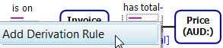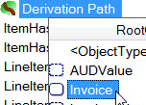

⇨

⇩

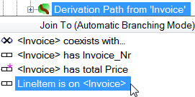

Select the LineItem role, open its drop-down list and select <LineItem> has Quantity.

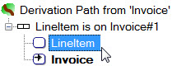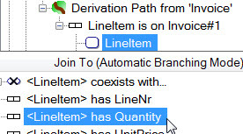

⇨

Move up to the LineItem#1 is on Invoice#1 fact type, select the LineItem role (this is the Invoice.lineItem role), open its drop-down list, and select <LineItem> has UnitPrice.

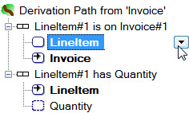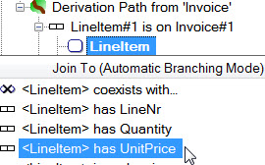

⇨

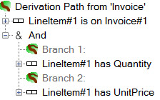This action was performed on LineItem in Automatic Branching Mode, so NORMA split the path into two conjunctive branches stemming from LineItem, as shown.

We now need to add a calculation to multiply the quantity by the unit price to compute the subtotal. We want to add this calculation to the Invoice.lineItem role, but to invoke the Add Calculation facility you need to go all the way up to the Derivation Path from ‘Invoice’ header.

Right-click Derivation Path from ‘Invoice’ header, chose Add Calculation from its context menu, and select the multiply operator (*) from the function list.

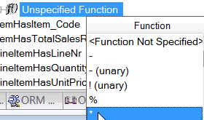

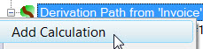

⇨

For the left operand, expand Path Variables in the DataSource property, and select Quantity. For the right operand, expand Path Variables in the DataSource property, and select UnitPrice.

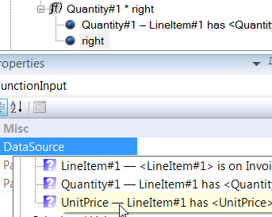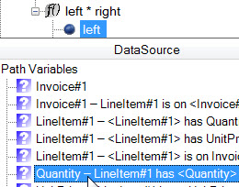

⇨

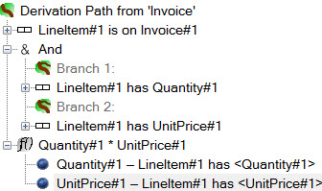At his stage, we have entered the derivation for the subtotals, and the derivation path appears as shown opposite.

Now we sum over the multiplication results. Go up to the Derivation Path from ‘Invoice’ header, right-click that header, chose Add Calculation from its context menu, and select the sum function from the function list.

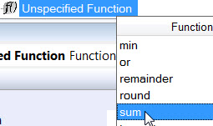

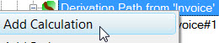

⇨

For the Data Source property, expand Calculated Values, and select Quantity#1 * UnitPrice#1. The derivation path now displays as shown.

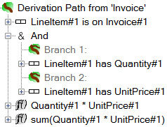

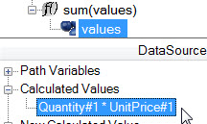

⇨

To declare that the aggregation context (grouping criterion) for the sum function, select the sum function expression, and then open the drop-down list for its AggregationContext property and check the check box for Invoice#1.

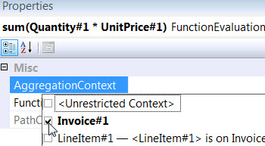

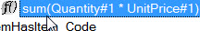

⇨

Now bind the derived roles to the relevant items in the derivation path in the usual way, by selecting the Derivation Path from ‘Invoice’ header, setting the Derivation Source1 property to the path variable Invoice#1 and the Derivation Source2 property to the calculated value sum(Quantity#1 * UnitPrice#1).

That completes the derivation rule. The Model Browser display is as shown below. To see the binding of derived roles to their sources, select the derivation path header and then the derivation source properties. Alternatively, select each derived role and view its Derivation Source. To see the aggregation context for the sum function, select it and then view its AggregationContext property. For convenience, these are displayed here on the right of the screenshot.

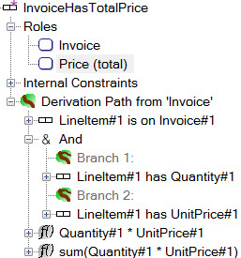







To view the verbalization of the derivation rule, select the derived fact type (in either the diagram window or the Model Browser) and open the Verbalization Browser.

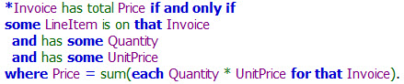

If you wish to display this relational style verbalization on the ORM diagram, copy and paste it into the Model Note. If you instead wish to display the FORML version given earlier, manually enter it in a Model Note, as shown below. The derivation rule for Item has total- SalesRevenue may be entered in a similar way, and is left as an exercise.

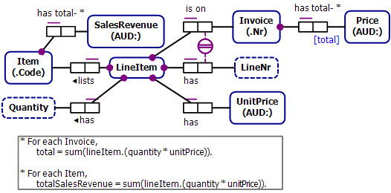

The functions currently supported in NORMA are listed below.

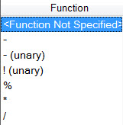

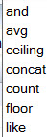

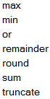



## Joining from Multiple Roles of an *n*-ary Fact Type

When you perform joins in a derivation path, you will typically invoke the automatic join mode in one of the following two ways:

* *Branch from the root object type* by moving up to the head of the path (Derivation Path from Root), opening its drop-down list, and selecting the relevant role from the fact type that you want to add on a separate branch. By default, an **and**-branch is formed (e.g. Person smokes **and** drinks). If you instead wish an **or**-branch or an **xor**-branch, you explicitly choose that operator before selecting the branch role.
* *Join from a role of a fact type in the path*, by selecting the role, opening its drop-down list, and selecting the relevant role from the next fact type that you want to add to the path. If you have previously joined from the same role, then an **and**-branch is formed by default (e.g. Company employs Person **who** is intelligent **and** is industrious). You may change this to an **or**-branch or an **xor**-branch by choosing the relevant operator.

You can also manually join roles on different branches under an **and**-operator by explicitly correlating their variables (e.g. see Person fully communicates in Language in Section 2.3).

All the joins in the examples discussed so far have been performed using one of these ways.

In rare cases, you might want to *join from multiple roles of an n-ary fact type* in the path. This is also known as an *intra-fact type split*. To illustrate this possibility, we will now discuss ways of entering the derivation rule for the derived unary fact type in the ORM schema shown in Figure 2‑10.



Figure ‑ The derivation rule involves joins from two roles of the ternary fact type

In FORML, the derivation rule may be declared using either of the following formulations:

**\***Person is a typical sportsperson **iff**

Person played **some** Sport for **some** Country **that** is large,

**where that** Sport is popular.

**\***Person is a typical sportsperson **iff**

Person plays **some** Sport (**that** is popular) for **some** Country **that** is large.

You may visualize the derivation path and binding as shown opposite. In the derivation path, roles with the same color fill are joined. This picture reflects the process we will use to enter the derivation rule in NORMA. However, once you make the join on the Sport roles, the Model Browser display will radically alter, instead depicting the derivation path with multiple branches.

To start the derivation path, right-click the derived fact type, choose Add Derivation Rule, and select Person as the root object type.

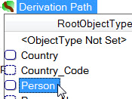

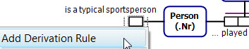

⇨

Select <Person> played Sport for Country, then select its Country tail role, open its drop-down list, and join to Country’s isLarge role by selecting <Country> is large.

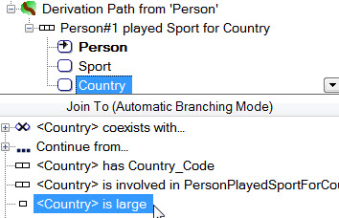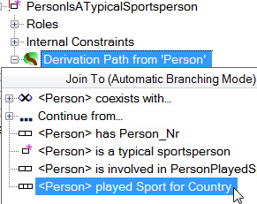

⇨

At this stage, the derivation path looks as shown, starting at Person as the root object type, continuing through the ternary fact type Person plays Sport for Country, and tail-joining on Country to end in the fact type Country is large.

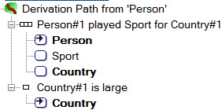

Everything has behaved as expected up to this point. But now we want to join the Sport role (a middle role of the ternary) to the first role of Sport is popular. To do this, select the Sport role in the ternary, open its dropdown, and continue the path from Sport by choosing <Sport> is popular. That completes the derivation path, as shown below. Notice that the Country#1 is large and Sport#1 is popular conditions appear on separate branches of a conjunction, and that Sport#1 is popular is prefaced by “… (from Sport#1)” to indicate an intra-fact type split that continues from the Sport role of the ternary. The common suffixes (#1) on the relevant roles indicate that they are conceptually correlated, so you may think of the derivation path just we originally visualized it.

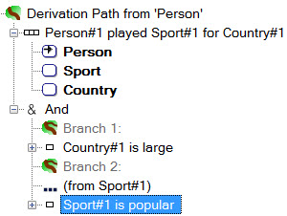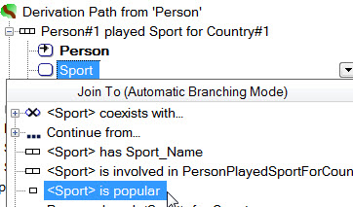

⇨

To complete the derivation rule, select the Derivation Path from ‘Person’ header, open the dropdown for the DerivationSource1 (Person) property, expand Path Variables and choose the Person#1 variable as shown.

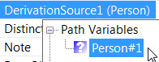

 ⇨

To view the verbalization of the derivation rule, select the derived fact type and open the Verbalization Browser.

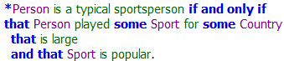

To display this verbalization on the ORM diagram, copy and paste it into a Model Note in the usual way.

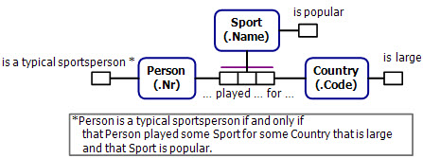

An alternative way to formulate the derivation path is to join on Sport before joining on Country. This alternative approach behaves similarly to the approach just discussed.

For *n*-ary cases like the one just discussed, there is an alternative approach that uses *multiple roots* (e.g. one for Person and one for Sport) and explicitly correlates relevant role occurrences between branches. Multi-rooted paths are discussed in a later section.

## Objectification

In the ORM schema shown in Figure 2‑11(a), the fact type Student enrolled in Course is objectified as Enrolment[13]. The Enrolment object type is independent (as shown by the appended “!”), meaning instances of it may exist without playing any other explicit fact roles. So its role in the fact type Enrolment resulted in Rating is optional—we can know that a given student enrolled in a given course without knowing the rating that student will eventually get (e.g. the final exam for that course might not have been held yet).

In ORM 2, the entity type resulting from objectifying a fact type is distinct from the fact type, but is in 1:1 correspondence with it, and is implicitly connected to the component object types by link fact types, as shown in Figure 2‑11(b). Here the *link fact types* (shown with dashed lines) are Student is involved in / involves Enrolment and Course is involved in / involves Enrolment. Implicitly, the Enrolment object type is coreferenced via these link fact types, and the join equality constraint enforces the 1:1 correspondence[14].



Figure ‑ ORM schema (a) is equivalent to ORM schema (b)

By default, NORMA does not display the link fact types on the diagram. To see them, right-click Enrolment and choose Select in Model Browser from its context menu, expand the fact type StudentEnrolledInCourse, and then expand Implied Fact Types. You can also see these reading by selecting a role of the objectified fact type, and then expanding Implied Fact Type Readings in the ORM Reading Editor. By default, NORMA uses the forward and inverse predicate readings “is involved in” and “involves”.

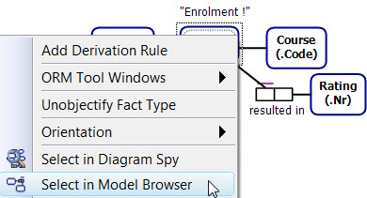

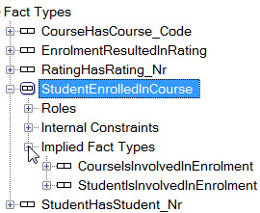

⇨

If desired, you can edit these predicate readings to provide more natural readings for the link fact types. Let’s make these changes now. In the Model Browser, select the link fact type CourseIsInvolvedInEnrolment, open the Fact Editor, edit the predicate readings as shown, and press Ctrl+Enter to commit the changes.

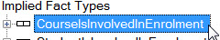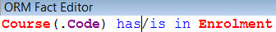

⇨

In the Model Browser, select the link fact type StudentIsInvolvedInEnrolment, and in the Fact Editor edit the predicate readings as shown, and press Ctrl+Enter to commit the changes.

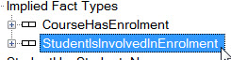

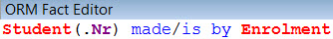

⇨

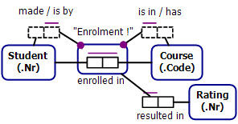If you wish to see the link fact types on the diagram (as shown opposite), select them in the Model Browser and drag them onto the document window. Refine their display as desired (e.g. right-click the Enrolment is in Course fact type and choose Orientation > Reverse Role Order from its context menu).

To remove them from the diagram, select them and press Delete (or Ctrl+Delete, depending on the Delete Key Behavior settings in the ORM Designer page of the Options dialog). Although not displayed on the diagram, the link fact types still remain in the model.

Now suppose that we want to add the fact type Student for Course got Rating, and derive this from the other fact types. One way to specify the derivation rule is FORML is shown below. The body of this derivation rule navigates from the Enrolment objectification type to Student, Course and Rating using two link predicates and one ordinary predicate.

**\***Student for Course got Rating **iff**

**some** Enrolment is by Student

**and** is in Course

**and** resulted in Rating.

Conceptually, this addition leads to a schema equivalent to that of Figure 2‑12.



Figure ‑ The ternary fact type is derived from the link fact types and the rating fact type



To formally enter this derivation rule in NORMA, we first specify the derivation path starting with Enrolment as the root object type and then conjunctively navigate to Student, Course and Rating. The Enrolment roles with gold fill are correlated (conceptually joined). To complete the rule we bind the derived roles to the path roles as shown in the visualization opposite.

Let’s now add the derivation rule in NORMA, starting with the schema shown below, where the ternary fact type has been added but is not yet derived. For explanatory purposes, the link fact types are displayed. Right-click the derived fact type, choose Add Derivation Rule, and select Enrolment as the root object type, then continue the path by selecting <Enrolment> is by Student.

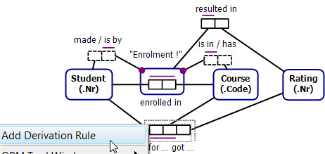

⇩

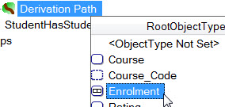

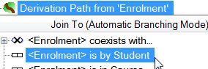

⇨

Now move the cursor up to Derivation Path from Enrolment, open the drop-down list, and select <Enrolment> is in Course. NORMA will automatically create an **and**-split so there are now two branches.

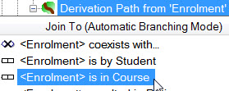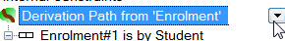

⇨

Now move the cursor up again to Derivation Path from Enrolment, open the drop-down list, and select <Enrolment> resulted in Rating.

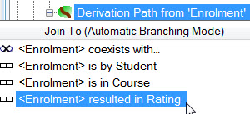

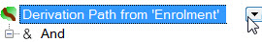

⇨

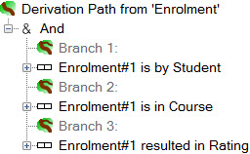That completes the derivation path There are now three branches under the And operator as shown. The Enrolment roles have been automatically correlated, as shown by displaying with the same suffix (Enrolment#1).

To complete the derivation rule, select the Derivation Path from ‘Enrolment’ header, and for each of the three DerivationSource properties open its dropdown, expand Path Variables, and choose the relevant variable (Student, Course, or Rating) to obtain the following role bindings.

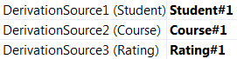

That completes the derivation rule entry. The rule verbalization is viewable in the Verbalization Browser.

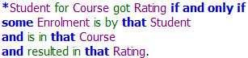

To view the derivation rule on the diagram, copy and paste the verbalization text into a Model Note as shown below.

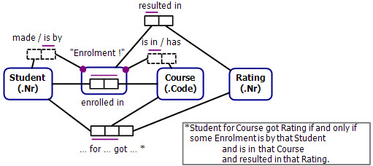

The derivation rule just considered involved *navigating out from an objectification*. NORMA also allows you to *navigate into an objectification* by traversing link fact types in the other direction. To illustrate this feature, we’ll now reformulate the derivation rule for the ternary by both navigating into the objectification and navigating out from it, as in the following FORML version of the rule:

*Student for Course got Rating **iff**

Student made **some** Enrolment

**that** is in Course **and** resulted in Rating.

To enter this derivation rule in NORMA, we first enter the derivation path starting with Student as the root object type, then use the fact type Student made Enrolment to navigate to Enrolment, and then **and**-split into two branches, one navigating to Course and the other to Rating.

To complete the derivation rule, we bind the derived roles, as shown in the visualization opposite. The Enrolment roles with gold fill are correlated (conceptually joined).

To do this in NORMA, delete any existing Derivation Path for the ternary fact type, right-click the ternary and choose Add Derivation Rule.

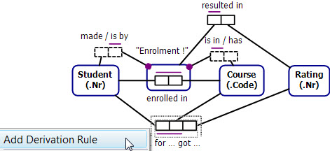

Now select Student as the root object type, then select <Student> made Enrolment.

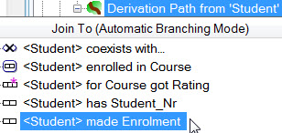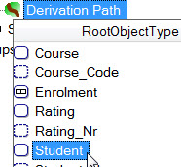

⇨

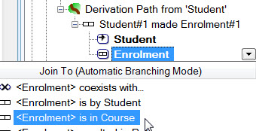Now select the Enrolment role of this fact type, open its drop-down list, and select <Enrolment> is in Course.

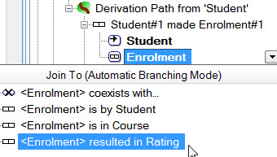Now move up to the Enrolment role of the first fact type, open its drop-down list, and select <Enrolment> resulted in Rating.

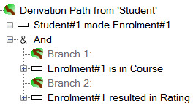

NORMA branches the path as shown. That completes the derivation path.

To complete the derivation rule, select bind the derived roles to the relevant Path Variables in the Derivation Source properties, as discussed earlier.

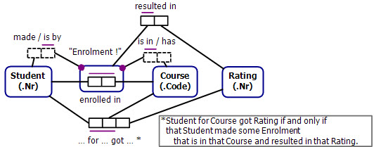To view the rule verbalization, select the derived fact type and open the verbalization Browser. The verbalization differs from that given earlier, reflecting the decision to start the derivation path at Student instead of Enrolment. To display the rule on the diagram, copy and paste it to a Model Note.

## Cartesian Products

Given any sets *A* and *B*, their *Cartesian product* *A* × *B*, is the set of all ordered pairs with members belonging to *A* and *B* respectively, i.e. *A* × *B* = {(*x*, *y*) | *x* ∈ *A* & *y* ∈ *B*}. The ORM schema in Figure 2‑13 includes the derived fact type Person may pair with Person, which could be used to list all pairs of people of opposite gender (e.g. to help choose mixed doubles teams for a tennis match). This list is the Cartesian product of person pairs, where the persons are of opposite gender. Using “<>” for “is not equal to”, the derivation rule is expressed in FORML thus:

**\***Person1 may pair with Person2 **iff**

Person1 is of Gender1 **and** Person2 is of Gender2

**and** Gender1 <> Gender2.



Figure ‑ The derivation rule derives the Cartesian product of sets of people of opposite gender

One way of visualizing the derivation rule is shown opposite. The derivation path involves two separate copies of the Person is of Gender fact type, using subscripts to distinguish the Person and Gender variables. An inequality operator “<>” is applied between the Gender variables. The roles in the derived fact type are then bound to the roles played by Person1 and Person2.

An alternative way to view the derivation rule is shown opposite. Here the pseudo-predicate “*coexists with*” explicitly captures the two existential quantifiers for the Person1 and Person2 variables (these quantifications are implicit in the above view). The path continues along the second branch by adding Person2 is of Gender2, and then the inequality between genders is added as a path condition.

This visualization corresponds more closely to NORMA’s user interface for entering derivation rules, although the inequality is treated as a function calculation rather than as extending the path with a binary fact type

To add the derivation rule in the Model Browser, right-click the fact type Person may pair with Person, chose Add Derivation Rule, and select Person as the root object type.

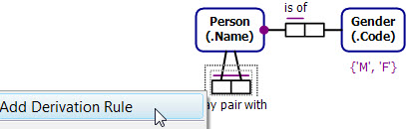

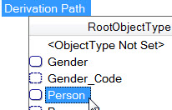

⇨

Open the drop-down, and select Person is of Gender to extend the path[15]. We’ll use the Person role occurrence in this path for the first person in our pair of persons.

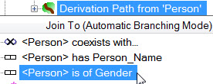

Now go back to Derivation Path from Person. To get the second person, there’s no point in adding an **and**-branch from the same root, because the same person variable would be then used for both the branches. To obtain a different Person variable, open the drop-down list, expand the [+] button before Person coexists with … and choose Person from the list of available object types.

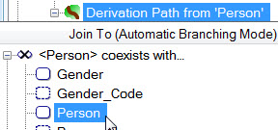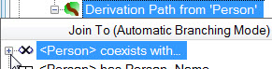

⇨

This creates a second branch with a new Person variable (Person#2) different from the earlier Person variable (now named Person#1). The “*coexists with…*” predicate reading has the semantics of “**where** **exists**”, and thus produces the Cartesian product of the two branches. The user interface visually suggests this Cartesian product (or cross join) operation by the cross-join icon that precedes “Person#1 coexists with Person#2”. Now continue the path from Person#2 by opening the drop-down list for this coexistence fact type, and selecting Person is of Gender.

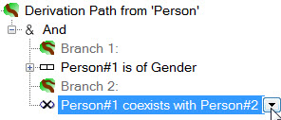

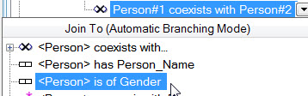

⇨

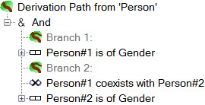The derivation path now displays as shown. Although the Person variables are distinct, the two Gender role occurrences are unrelated, and have no variables yet assigned to them. We need to add the condition that these two genders are not equal. NORMA treats the inequality operator “<>” as a function, so to add this condition we need to add a function calculation to the path and then declare that calculation to be a path condition.

To do this, right-click Derivation Path from Person, select Add Calculation from its context menu, choose <> as the function, then for the left argument’s Data Source, open Path Variables and select Gender from Person#1 is of Gender. Then for the right argument’s Data Source, open Path Variables and select Gender from Person#2 is of Gender.

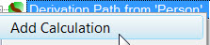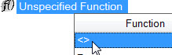

⇨

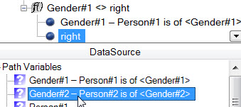

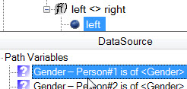

⇨

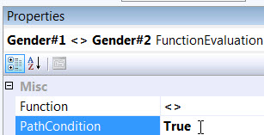That adds the calculation to the path, but we still need to declare it as a path condition (because a function calculation could be used instead as input to another function calculation or as a derivation source for the final projection). To *declare the inequality as a path condition*, select the calculation and toggle its PathCondition property to True (by default, this property is set to False).



⇨

Now select the Derivation Path from ‘Person’ header, and bind the DerivationSource properties of the derived roles to the Path Variables Person#1 and Person#2.

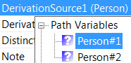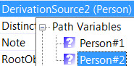

That completes the derivation rule entry. Select the derived fact type and open the Verbalization Browser to see its verbalization.

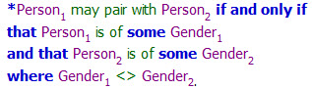

To display the rule on the diagram, copy and paste it to a Model Note.

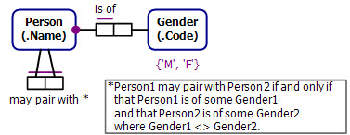

As the derivation rule stands, each unordered pair of persons will appear twice in the population of the derived fact type, once with the male ordered first and once again with the female ordered first. If say, you wish each pair to be shown just with the male first, then you could use a different fact type based on the following FORML rule

**\***Person1 may pair as male with female- Person2 **iff**

Person1 is of Gender ‘M’ **and** Person2 is of Gender ‘F’.

The entry of this derivation in NORMA is left as an optional exercise.

## Multi-pathed Derivation Rules

The ORM schema in Figure 2‑14 identifies employees by their employee numbers. Each employee has a family name and optionally has a preferred given name. Employee names (which are not necessarily identifying) are derived using the FORML rule shown, where the “+” operator denotes string concatenation. If the employee has a preferred given name, this is prepended to a space and then the family name. If the employee has no preferred given name (as may be the case in some Asian cultures), then the employee name is just the family name.



Figure ‑ A multi-pathed derivation rule

A relational table for this schema is shown below with a small sample population

|  |  |  |  |
| --- | --- | --- | --- |
| ***empNr*** | *familyName* | *prefGivenName* | *empName* |
| 1 | Jones | Eve | Eve Jones |
| 2 | Ah |  | Ah |

In NORMA, we cannot enter the derivation using just a single derivation path, because the derived role for employee name would then need to be bound to a single derivation source. In this example, however, there are two derivation sources for the derived employeename role, one for each of the two cases considered above. To cater for this situation in NORMA, we need to specify *multiple derivation paths*, each with its own role binding option. For this example, there will be just two derivation paths. Let’s see how to do this now.

Right-click the Employee has EmployeeName fact type, select Add Derivation Rule from its context menu, and select Employee as the root object type.

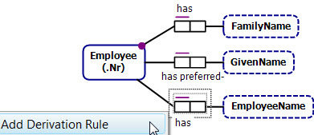

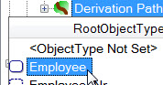

⇨

Continue the path from Employee by opening its drop-down list and selecting the fact type Employee has FamilyName. Now go back to the Derivation Path header, open its drop down list, and select Employee has preferred GivenName.

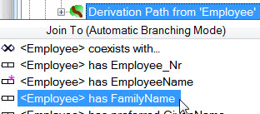

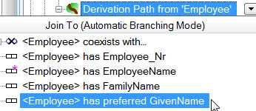

⇨

The fact type Employee#1 has preferred GivenName appears on Branch 2 of the path. Select this fact type, go to its IsNegated property and double-click it to toggle its value from False to True.

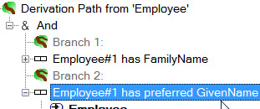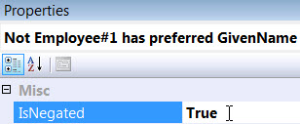

⇨

That completes the first derivation path, which handles the case where the employee does not have a preferred given name. The path should display as shown at the top left of the next page.

We now need to add a second derivation path to cater for the case where the employee does have a preferred given name. To do this, right-click the Derivation Path header and select Add Path from its context menu.

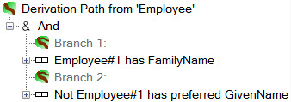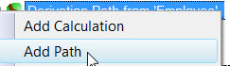

⇨

This opens up a second path, Path2. The previous path is now named Path1. In Path2, select Employee as its root object type, open its dropdown list, and select Employee has FamilyName.

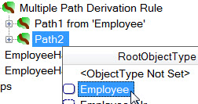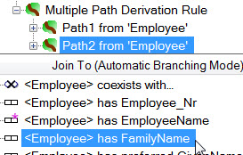

⇨

Go back to the Path2 header, open its dropdown list, and select Employee has preferred GivenName. Then right-click the Path2 header, and select Add Calculation from its context menu.

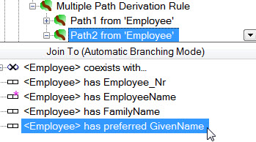

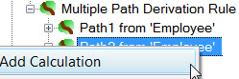

⇨

For our first calculation we want to concatenate the preferred given name to a space character. Select the “+” function from the function list[16]. The “+” operator may be used to add numbers or concatenate strings, depending on what kinds of arguments (numeric or string) you give it. For the DataSource of the left argument, expand Path Variables and select GivenName.

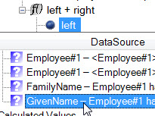

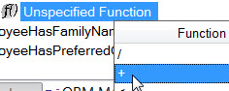

⇨

For the DataSource of the right argument, expand ConstantValue, type the string ' ' (single quotes around a space) and press Enter. The function calculation now displays as shown.

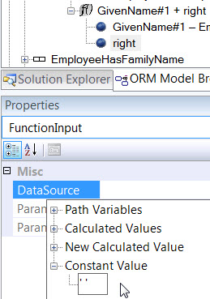

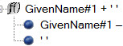

⇨

For our second and final calculation we want to concatenate the result of the first calculation to the family name. Right-click the Path2 header, select Add Calculation from its context menu, and then select “+” from the function list. For the DataSource of the left argument, expand Calculated Values and select GivenName#1 + ' '. For the DataSource of the right argument, expand Path Variables and select FamilyName.

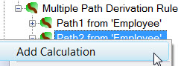

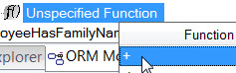

⇨

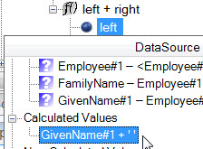

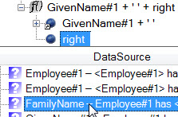

⇨

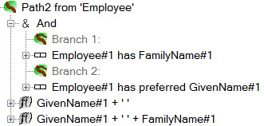That completes the second derivation path, which should display as shown.

To complete the derivation rule we need to bind the derived roles of the Employee has EmployeeName fact type to the relevant derivation sources in the two paths. We do this one path at a time.

Select the header Path1 from Employee, go to its DerivationSource1 property, expand Path Variables, and select Employee#1. Then go to its DerivationSource2 property, expand Path Variables, and select FamilyName.

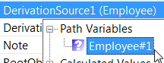

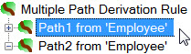

⇨

⇩

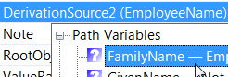

Now select the header Path2 from Employee, go to its DerivationSource1 property, expand Path Variables, and select Employee#1. Then go to its DerivationSource2 property, expand Calculated Variables, and select GivenName#1 + ‘ ‘ + FamilyName#1.

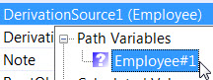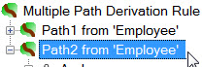

⇨

⇩

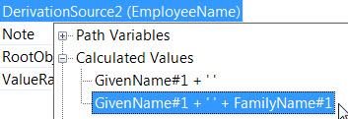

That completes entry of the derivation rule for the derived fact type. It’s always a good idea to view the rule verbalization to check that you entered the rule correctly. To do so, select the derived fact type on either the diagram or the Model Browser, and open the Verbalization Browser. You should see the rule verbalization displayed below.

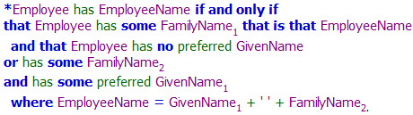

To display this version of the rule on the ORM diagram, copy and paste it into a Model Note in the usual way.

In Path2, we entered the calculation for GivenName + ' ' + FamilyName by entering a calculation for the first concatenation and then entering a second calculation for the final concatenation. It is also possible to do it in one go by embedding GivenName + ' ' as a *new calculation* that provides the left operand of the overall concatenation with FamilyName. To do this, select Path2 from Employee, choose Add Calculation and then + as the function as before.



⇨

For the DataSource of the left operand, expand *New Calculated Value* and select the “+” operator. This opens up embedded left and right argument slots for the operator. For the left operand, select the Path Variable GivenName#1 for its DataSource. For the DataSource of right operand expand Constant Value and enter ' '. That embedded concatenation is now the left operand of the overall concatenation. Complete the overall concatenation, by choosing the Path Variable FamilyName#1 as the DataSource for its right operand.

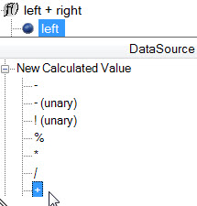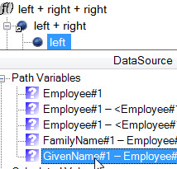

⇨

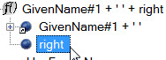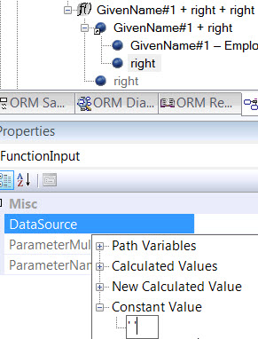

⇨

⇩

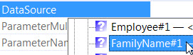

The rest of the rule entry and its verbalization is the same as before.

## Shared Path Derivation Rules

The ORM schema in Figure 2‑15 contains two derived fact types. In ORM, asserted fact types must be atomic but derived fact types do not need to be atomic. The derived ternary is not atomic, because it has an embedded functional dependency from its customer role to its region role. Its fact instances can be rephrased without information loss as a conjunction of instances of the three binary fact types used in its derivation.



Figure ‑ The two derivation rules have the same derivation path

The FORML derivation rules each use a derivation path that may be expressed basically as “Customer lives in Region **and** bought Car **that** is of CarModel”. The conjunction of these two rules is equivalent to the following *multi-headed rule*, which derives both fact types from the same rule body:

CarModel sold in Region **and** Customer in Region bought Carmodel

**iff**

**that** Customer lives in **that** Region

**and** bought **some** Car **that** is of **that** CarModel.

Such multi-headed rules are commonly used in languages like DatalogLB to avoid the additional coding incurred by repeating the same rule body in multiple rules.

Although NORMA does not directly support multi-headed rules, it does allow a derivation rule to *share (or reuse) a derivation path* specified in another rule. Such path sharing avoids the need to enter that path again. To illustrate this path sharing, we will now add the derivation rule for CarModel sold in Region in the usual way, and then share its path when entering the derivation rule for the Customer in Region bought Carmodel fact type.

Right-click the fact type CarModel sold in Region, select Add Derivation Rule, then and select Customer as the root object type for the derivation path.

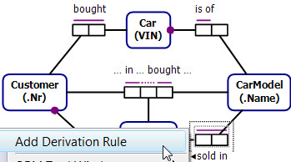

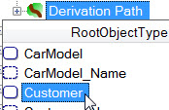

⇨

Continue the path from customer by selecting Customer lives in Region. Then go back to the Derivation Path header, open its dropdown list and select Customer bought Car.

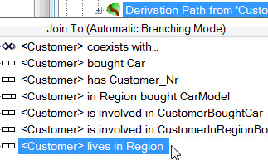

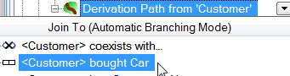 ⇨

Now select Car on Branch 2, open its dropdown list, and select Car is of CarModel to complete the derivation path.

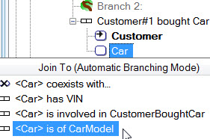

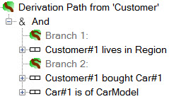

⇨

Now bind the derived CarModel role to the CarModel path variable by expanding Path Variables in its DerivationSource property and selecting CarModel. Similarly, bind the derived Region role to the Region path variable.

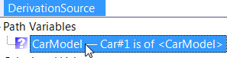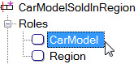

⇨

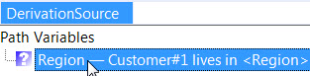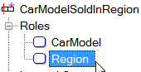

⇨

That completes entry of the first derivation rule. Select the derived fact type and open the Verbalization Browser to see the rule verbalization.

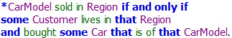

We could enter the second derivation rule in a similar way, but we can avoid the work of entering the same derivation path again by simply reusing the path from the first rule. Let’s do this now. Right-click the fact type Customer in Region bought CarModel and select Add Derivation Rule. Ignore the prompt to enter a root object type, and instead right-click the Derivation Path header and select *Add Shared Path*.

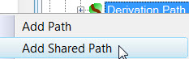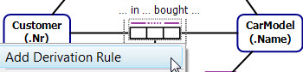

⇨

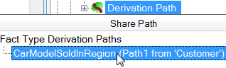

This opens up a Share Path pick list of derivation paths already defined in the model. Select the path from the rule you just defined (CarModelSoldInRegion). This adds the path to the derivation rule you are currently defining. ⇩

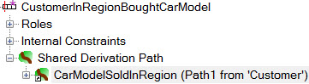

Now expand Roles, and bind the derived roles by expanding and selecting the DerivationSource Path Variables in the usual way.

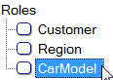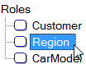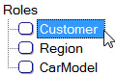

⇩ ⇩ ⇩

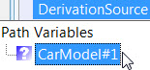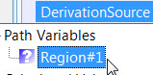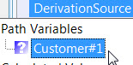

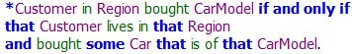That completes entry of the second derivation rule. View its verbalization in the usual way. To see the rules on the ORM diagram, copy and paste the verbalization text to a Model Note.

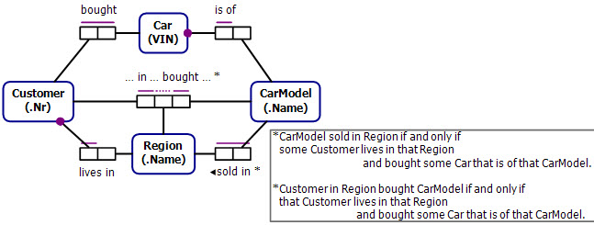

## Semiderived Fact Types

The ORM schema in Figure 1‑1 is like the example discussed in section 2.2, except that the fact type Person lives in Country is now *semiderived* instead of fully derived. If we know that Ann lives in Hawaii and that Hawaii is in the USA we can derive that Ann lives in the USA. If we know that Terry lives in Australia but don’t know the state in which he lives, we can simply assert that he lives in Australia. The semiderived status of the fact type is indicated graphically by a “+” superscript, and textually by use of “**if**” instead of “**iff**” in the derivation rule.



Figure ‑ The fact type Person lies in Country is semiderived

To enter the derivation rule in NORMA, use the same procedure as that discussed in section 2.2. This results in the following display in the Model Browser.

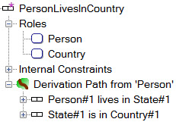





To declare the fact type semiderived, open its DerivationStorage property and change its entry from Derived to Asserted or Derived. Another way to other way to do this is to select the Derivation Path header and change its Completeness property to Partially Derived.

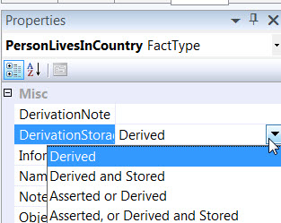

 ⇨

or ⇨

To see the verbalization of the rule, select the semiderived fact type and open the Verbalization Browser.

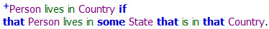

To see the rule on the ORM diagram, copy and paste the verbalization text into a Model Note.

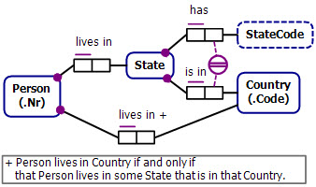

If you wish to also store the derived instances, select the fact type and change its DerivationStorage entry to Asserted, or Derived and Stored. This indicates that whenever the facts used to derive the relevant instance of Person lives in Country are inserted or updated, the derivation should be carried out and the resulting fact stored.

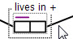

 ⇨

You can also choose this option by selecting the Derivation Path header, and setting its Storage property to Stored.

This semiderived-and-stored (i.e. Asserted, or Derived and Stored) status is indicated graphically by a double plus sign “++” on both the diagram and in the verbalization. If you wish this change to appear in a Model Note then update the Model Note accordingly.

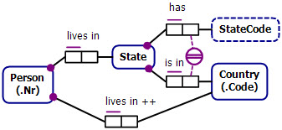

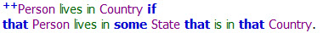

## Modifying Derivation Rules

This section discusses some ways to modify an existing derivation rule, either to correct a mistake or to change the intent of the rule. The ORM schema in Figure 2‑17 includes the derived fact type Person drives expensive- CarModel, with its derivation rule specified in FORML. The derivation path navigates from Person drives Car to Car is of CarModel and then to CarModel is expensive. Roles joined in the derivation path are highlighted in the same color.



Figure ‑ The derivation projects Person and CarModel from the highlighted join path

Using techniques discussed earlier, you can enter this rule in NORMA as a linear derivation path, and then project on the Person and CarModel variables, to give the following result.

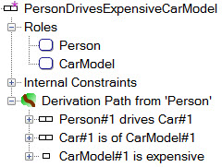





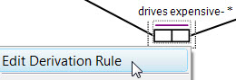However, suppose that we made a mistake, ending the path with CarModel#1 is cheap instead of CarModel#1 is expensive. To edit a derivation rule, select it directly in the Model Browser or right-click the derived fact type on the ORM diagram and select Edit Derivation Rule from its context menu.

The easiest way to fix this mistake is to select CarModel#1 is cheap, and delete it, either by pressing the Delete key, or by right-clicking it and selecting Delete from Model from its context menu.

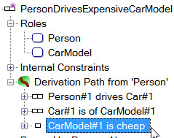

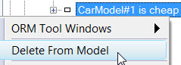

⇨

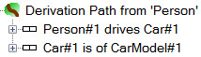The derivation path is now displayed with just the first two fact types, as shown opposite.

To add the correct fact type, expand Car#1 is of CarModel#1 to show its roles, then select the CarModel role, open its drop-down list, and select <CarModel> is expensive.

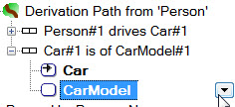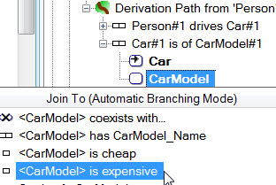

⇨

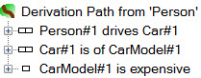The derivation path is now correct, as shown opposite.

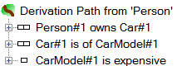Suppose now that when we entered the original derivation rule we made a different mistake, by wrongly selecting Person owns Car instead of Person drives Car, leading to the path shown opposite. In this case, the mistake is very early in the path.

While we could fix this mistake by deleting the whole path and starting again, it is possible to replace just the Person#1 owns Car#1 fact type with the correct one, while leaving the rest of the path intact. To do this, select Person#1 owns Car#1 fact type and delete it (e.g. by pressing the Delete key). This removes the fact type, and marks the following fact type (formerly displayed as Car#1 is of CarModel#1) as having an unresolved supertype. In general, we need to now go to the path node that is immediately before the deleted fact type, and open its drop-down list. In this case, the previous node is the path root, which is displayed as the header Derivation Path from ‘Person’.

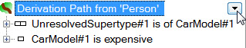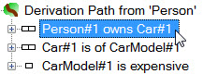

⇨

On opening the drop-down list, the Join to (Automatic Branching Mode) header appears. Click this once to toggle its setting to Join To (Freeform Insert Mode).

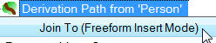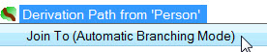

⇨

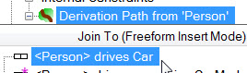Now select the fact type <Person> drives Car which we want to replace the removed fact type.

This inserts the fact type into the path, but both it and the following fact type have an unresolved supertype error message. To fix this error, right-click the Car role and choose Insert as Next Step from its context menu[17].

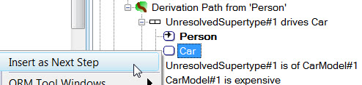

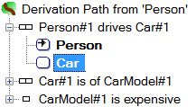This explicitly declares the join between the Car roles in these fact types, and the path is now correct, as shown opposite.

As this is the last fix we want to make to the path, right-click the Derivation Path header and click its Join To header to switch it back to Automatic Branching Mode.

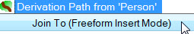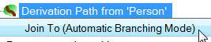

⇨

To finalize the derivation rule, select the CarModel role in the derived fact type, and set its DerivationSource to the path variable CarModel#1.

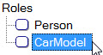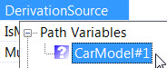

⇨

Open the Verbalization Browser to check that the verbalization agrees with the intent of the rule.



As you can see, freeform insert mode needs care to work with, but if ever you need to replace a fact type that occurs very early in a lengthy and complex derivation path, it provides the quickest way to do this.

Freeform insertion mode supports coexists and continuation branches in addition to the joined roles. Freeform insertion is not available for some selections. You can use it from:

* The last used role in a fact type. You can find the last role by looking at the LocalPathPosition and TotalPathPosition properties and finding the highest position.
* An unused role. Freeform inserting from an unused role adds the role after the current last role, then joins to it.
* Any ‘coexists’ or ‘continue’ node
* A ‘Branch...’ header node. This inserts at the top of the branch.
* A starting node, such as the top of the path.

You cannot freeform insert from a ‘split’ node (And, Or (Inclusive), etc). Also, Freeform Insert mode remains on where it is available the next time the dropdown is opened, so be careful.

# Adding Join Paths for Constraints

## Introduction

The ORM schema in Figure 3‑1(a) includes an external uniqueness constraint over the Building and RoomNr roles. This is equivalent to an internal uniqueness constraint over the compound derived fact type Room in Building has RoomNr (not shown here) that could be derived by conceptually joining the Room roles (shown with gold fill). When you enter this external uniqueness constraint in NORMA, the tool can automatically determine the join path because there is no other possibility for it.

However, in the schema shown in Figure 3‑1(b) the underlying join path intended for the external uniqueness constraint can’t be automatically determined, because there are many possibilities. For example, the join path might navigate from *A* to *D* via the *B S D* fact type, or via the *B T C* fact type, or via the implicit instance-level identity fact type (shown here with dashed lines) underlying the subtyping connection. To apply this external uniqueness constraint in NORMA, you have to explicitly indicate the join path.



Figure ‑ The uniqueness constraint’s join path in (a) is obvious, but in (b) it is indeterminate

As another example, consider the join subset constraint in Figure 3‑2, which NORMA verbalizes as: **If some** Advisor serves in **some** Country **then that** Advisor speaks **some** Language **that** is used by **that** Country. This constraint is directed from the (advisor, country) role pair forming the serves-in predicate, to the (advisor, country) role pair projected from the join path that conceptually joins the Advisor speaks Language and Language is used by Country fact types (the joined Language roles are shown with gold fill). NORMA automatically determines the join path from which the superset argument is projected, because there is no other possibility.



Figure ‑ The join path for the superset of the subset constraint can be automatically determined

Now consider the join subset constraint in Figure 3‑3. The join path underlying the superset argument of the constraint can’t be determined automatically, because there is more than one possibility for it. Our intent might be that the join path navigates from Consultant speaks Language via Language is supported in Product to Product is made by Company. However, a join path that navigates via the Language is unsupported by Product is also possible, so NORMA has no way to formally determine which is the join path we intend.



Figure ‑ The join path for the superset of the subset constraint can’t be automatically determined

To disambiguate the subset constraint, you need to explicitly specify the join path from which the (consultant, company) role-pair is projected to provide the superset argument for the constraint. Happily, you can *specify join paths for constraints in basically the same way you specify derivation paths for derived fact types*. So there is little more to learn in this regard. The next section discusses how to do this using this example. For interactive practice with this example, use the files Derivation27_AdvisorServesInCountry.orm and/or Derivation28_AdvisorServesInCountry2.orm.

## A Worked Example

The NORMA screenshot below shows the result of entering the ORM schema in Figure 3‑3, and selecting the join subset constraint. If you open the Verbalization Browser, you will see that NORMA verbalizes as much of the constraint as it can, and also includes an error message indicating that the join path for the second argument of the constraint (the superset argument) needs to be specified.

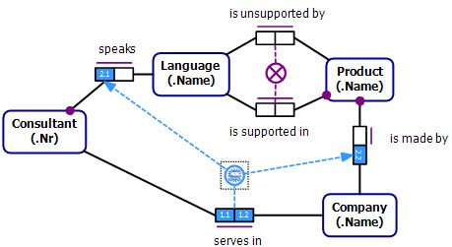

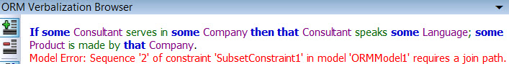

By default, the Verbalization Browser text includes *hyperlinks* (you can control this via the menu setting Tools > Options > ORM Designer > Verbalization > Alternate Verbalization Text > Core ORM Verbalization > Browser Settings). Click the error message, and the hyperlink will take you to the relevant section of the Model Browser where you can enter the join path for the role sequence forming the superset argument of the subset constraint[18].



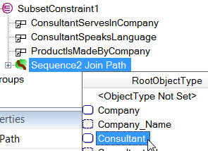An empty join path (Sequence2 Join Path) now appears for the superset join path of the constraint, with its drop-down list already open. Select Consultant as the root object type for the path.

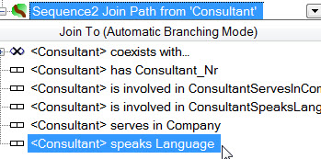Open the drop-down for Consultant, and continue the path by selecting <Consultant> speaks Language.

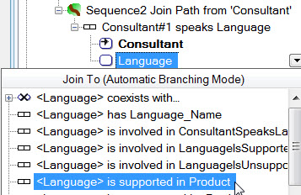Now select the Language role in this fact type, open its drop down list, and select <Language> is supported in Product.

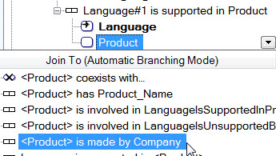Now select the Product role of this fact type, open its drop-down list and select <Product> is made by Company.

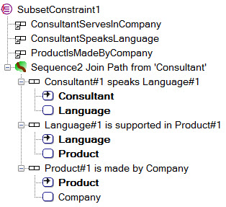The join path now displays as shown. Notice that the final Company role is not bolded, and Company is not subscripted in the fact type, so it is not yet included in the path. This isn’t a problem, since it will get inserted in the path automatically when we bind the derived Company role onto its source variable[19].

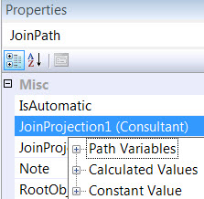That completes the join path for the superset argument of the subset constraint, but we still need to identify which role variables in it are to be bound to the roles in that constraint argument (similar to binding derived roles to path variables). Typically, as in this case, there is only one possible choice, and NORMA sometimes makes that choice for you automatically. In this case however, since we did not explicitly include the Company role in the join path, so it cannot be automatically assigned as a path variable. Hence, the subset constraint on the ORM diagram still displays with red line fill indicating an error state (and the error message is still displayed in the Verbalization Browser). To fix this, double-click the constraint shape, to invoke the display of the Properties window for the constraint join path.

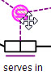

⇨

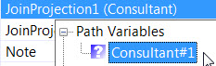For JoinProjection1 (Consultant), expand Path Variables and choose Consultant#1.

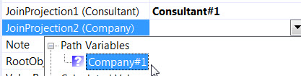

For JoinProjection2 (Company), open its drop-down list, expand Path Variables and choose Company#1.

The subset constraint is now correctly specified, as indicated by the removal of the red line fill on the constraint shape and the removal of the error message.

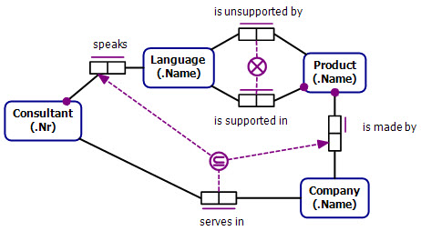

Select the subset constraint shape and open the Verbalization Browser to see the constraint verbalization.

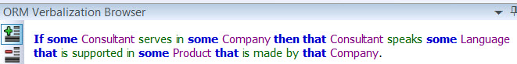

1. See http://en.wikipedia.org/wiki/Table_of_keyboard_shortcuts for a detailed list of general keyboard shortcuts for popular operating systems.
2. An alternative way to open a derivation path for Smoker is to right-click its diagram shape, choose Select in Model Browser from its context menu, and then right-click Smoker in the ORM Model Browser and choose Add Derivation Path.
3. If the ORM Model Browser does not appear, right-click in the Document Window to open its context menu and choose ORM Tool Windows > ORM Model Browser.
4. “Free form Insertion Mode” (reached by clicking the header button) should only be needed to repair paths broken by underlying model changes or user deletion.
5. Many toolbox items have additional behaviour if you click the toolbox item, then click the diagram, instead of simply dragging the item out. In this case, toolbox click/diagram click opens a dropdown in the properties window where you can paste the text. Use Ctrl+Enter to add an extra line to the note.
6. The ‘Show Description Tooltips’ property in the ‘Appearance’ section of the ORM Designer options page can be set to True to display these as tooltips for an element.
7. The “?” icon contains significantly more information than the normal text for any entry that has a bound variable number. Any truncated text also automatically produces a tooltip when hovering over the text. All of the dropdowns have size grab handles on the lower left that can be used to expand the dropdown size. The size for each type of dropdown will be remembered during your Visual Studio session.
8. Note that the variable name here is “Person#1” not “Smoker#1” or “MalePerson#1”. The displayed names are always based on the nearest shared supertype of the role players, combined with the starting object type for the lead roles in the path. It is possible to get a variable name that is not any of the role player names.
9. Using “∀” for the universal quantifier, “∃” for the existential quantifier, “&” for conjunction, and “≡” for material equivalence, the rule may be expressed in sorted, first-order logic thus: ∀*p*:Person ∀*c*:Country [*p* lives in *c* ≡ ∃*s*:State(*p* lives in *s* & *s* is in *c*)].
10. How a role is displayed is based on roles that are currently in the path (marked with numbers on the variable names) and roles that are not explicitly in the path. All roles not in the path are shown with the reading to indicate the role occurrence in question. Once a non-pathed role is chosen, it is given a # number and the display will change when the dropdown is reopened.
11. Although we could avoid branching by specifying a linear path that navigates to Language through the speaks predicate and then joins on Language and navigates back to Person via the writes-in predicate, this would still require an additional correlation on the Person roles, so this alternate approach actually involves more work.
12. The rule in sorted logic is: ∀*x*:Person ∀*y*:Person [*x* is an ancestor of *y* ≡ (*x* is a parent of *y* ∨ ∃*z*:Person (*x* is a parent of *z* & *z* is a parent of *y*))].
13. This spelling is used in countries such as England and Australia, but in the USA this should be spelled “Enrollment”.
14. While this picture using an equality constraint is conceptually correct, internally, NORMA implements the 1:1 correspondence more efficiently using proxy roles.
15. As an alternative, expand <Person> coexists with…, select Person, and change the Linear setting at the bottom to And. In this way, you can easily introduce multiple Person roots from which you can extend the path as needed.
16. As an alternative, you can use the *concat* function instead of “+” for string concatenation. 
17. Remove Step is also available. In general, combinations of Insert and Remove steps can be used to reorder the path, although you can’t Remove Step from an entry role.
18. An alternative but longer way to enter the join path is to begin by right-clicking the subset constraint and choosing Select in Model Browser from its context menu, and then in the Model Browser, expanding the entry for the subset constraint.
19. Though not needed, you could manually add the Company role to the path by right-clicking it and choosing Insert as Next Step. If you do this, NORMA will be able to automatically bind the Company role in the superset argument of the constraint to the Company role in the join path.